NAME:

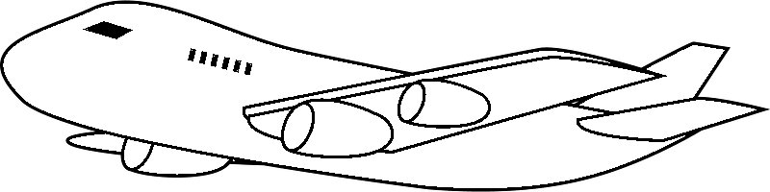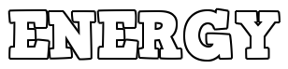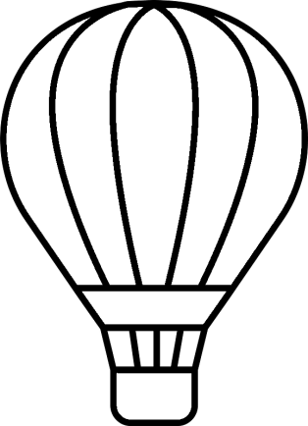

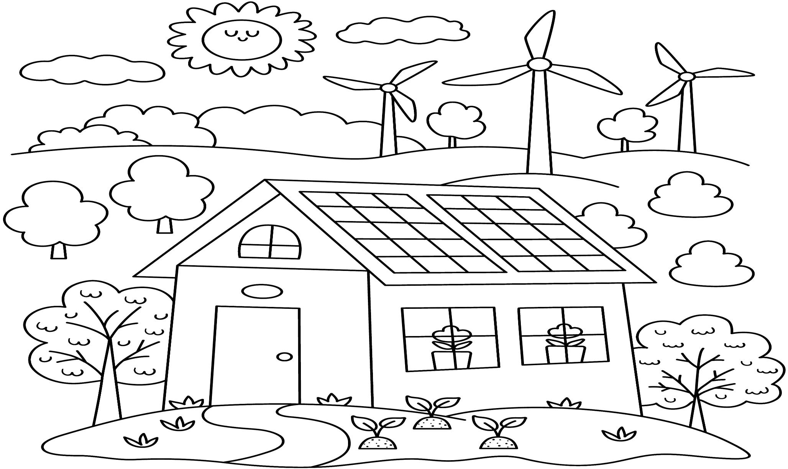

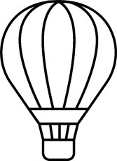

Name: 7

Curriculum Connection E.1



### What is Flight?

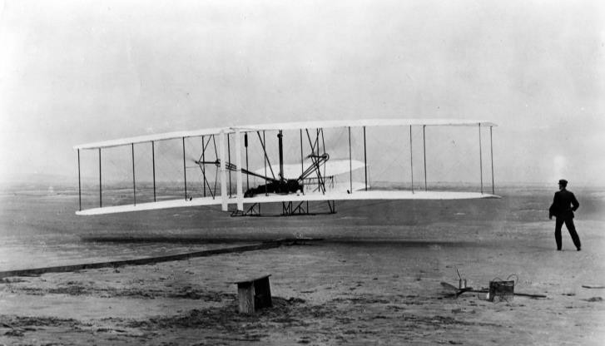

The Wright Flyer - 1903

The term **flight** refers to the action or process of flying through the air. For example, an eagle is in flight when they are soaring above the trees. An eagle is an example of how flight occurs naturally in our environment.

Flight also occurs using human-made structures called aircrafts. Examples of aircrafts are airplanes, jets, and helicopters. **Aviation** is the flying of an aircraft.

### History of Aviation

It took thousands of years for humans to fly like the birds around them. It wasn’t until December 17, 1903 that the famous Wright Brothers created the first successful airplane that flew only 120 feet. The aircraft was called the *Wright Flyer*.

### Interesting Facts about Flight

* Today’s Boeing 787 airplanes can fly 16,000km on a single tank of fuel. That is the length

of a flight from New York City to Sydney, Australia.

* The largest airplane is called the *Stratolaunch* with a wingspan longer than a football field!
* The Concorde is a special aircraft that takes passengers up to 60,000 feet, which is over 16km into the air. Passengers can see the curvature of the Earth!
* More than 80% of the population is afraid of flying
* Airplanes are crucial to today’s world. Businesses send their products across the world using airplanes, militaries use planes to defend their territories, and people travel across the world to travel or visit friends and family.
* A Boeing 747 has a maximum speed of 955km/h
* Only 5% of the world’s population have ever been on an airplane

Name: 9

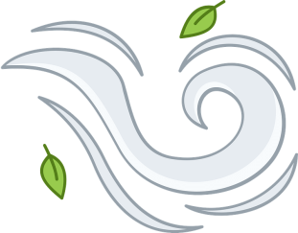

**What is Air?**

**Air** is the invisible gas that surrounds the earth. It is a mixture of mainly oxygen and nitrogen. Air is a fluid that is made of different air particles that are loosely held together in a gas form. A **fluid** is any substance that flows, which means air is a fluid as the gas flows in our atmosphere. The following 6 properties of air allow flight to be possible as objects and animals fly through the air.

Matching

Draw a line from the property of air to its explanation

Curriculum Connection E.1

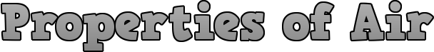

|  |  |
| --- | --- |
| **Property of Air** | **Explanation** |
| Air takes up space | Air particles have a lot of space between them so they can be squeezed together. |
| Air has weight/mass | Air exerts the same amount of force in all directions on an object. |
| Air is affected by heat | Blowing up the balloon makes the balloon expand |
| Air exerts pressure | An empty balloon weighs less than a blown up balloon |
| Air can be compressed | Air will heat up and cool down. When air heats up, the air particles move faster and when they cool, they slow down. |
| Air is affected by altitude | The higher you are, the lower the air pressure. Climbers need oxygen tanks on tall mountains. |

Name: 12

Curriculum Connection E.1



### Air is a Fluid

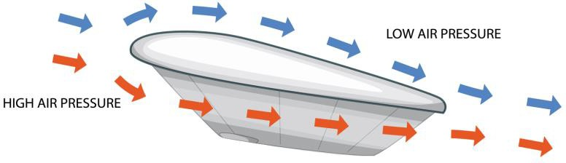

Our atmosphere is made up of air all around us. The air is a fluid. A **fluid** is any substance that flows. We have felt the flow of air when

we feel the wind blow on our bodies. The air around us is a mixture of different gases, mainly nitrogen and oxygen.

### Fluids Allow Flight

If air was not a fluid, nothing could fly through it. In outer space, it is a vacuum, meaning there is no air. With no fluid, it would be impossible to takeoff from the moon the same way airplanes takeoff on Earth. This is because airplanes use the properties of air to achieve lift off. To achieve lift, an airplane will travel quickly through the fluid in the air. The plane’s wings will send the airplane up as the air pressure increases below the plane.

A spaceship in orbit uses energy to move. The spaceship has an engine that burns fuel. The fuel is burned to make a hot gas that shoots backwards out of the exhaust. This pushes the spaceship in the opposite direction. With no fluid (air) in space, the spaceship is not fighting any air resistance (drag). It will travel very quickly once in orbit, with speeds of around 27,000 kph.

Questions

Answer the questions below using evidence from the text

|  |
| --- |
| 1) Why is air considered a fluid? |
|  |
| 2) Is air just empty space? Why is air important to flight? |
|  |
| 3) Why can’t a spacecraft take off like an airplane in space? |
|  |

Name: 13

Curriculum Connection E.1

## The Four Forces of Flight

In order for an aircraft to maintain a steady flight, it needs balance. Balance is achieved through an equilibrium of all forces acting upon the aircraft.

Weight, lift, thrust, and drag are the acting

forces on an aircraft.

# Lift

For an aircraft to travel a straight and level flight, lift must

be equal to weight. The thrust will produce speed depending on the amount of drag. If any forces change, the aircraft will move upwards, downwards, decelerate or accelerate.

# Drag Thrust

**Weight**

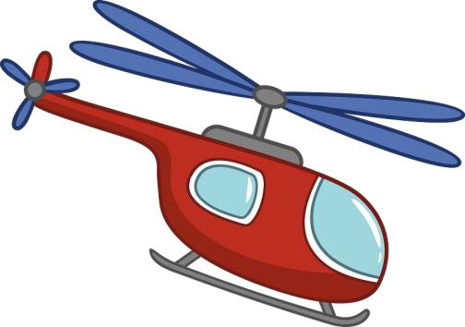

**Thrust (Propulsion) –** The engine of an aircraft creates the thrust that propels the plane forward. The engine pushes air backwards with the same force that the plane moves forward. This is in accordance with Newton’s 3rd Law of motion where a force in one direction produces an equal force in the opposite direction.

**Drag –** Drag is unwanted in flight as it forces the engine to work harder. When you stick your hand out of a window while you are driving, you will feel air pushing against your hand. You are causing a small amount of drag that affects your car’s motion. To reduce drag and increase efficiency, planes are streamlined and made aerodynamic.

**Lift** – Lift is a force generated by solid objects moving through a fluid. An airplane needs many parts to generate lift but the wings do most of the work as the plane flies through the air. As the airplane travels at fast speeds on a runway, the wings deflect the air downwards which in turn sends the wings upwards. This is Newton’s 3rd Law of Motion. The Bernoulli effect also explains how changes in air pressure generates more lift for airplanes. Together, these theories explain how lift is achieved for many aircrafts.

**Weight –** Weight is the force of gravity that acts in a downward direction, towards the center of the Earth. The weight of an aircraft affects how much lift and thrust an aircraft will need in order to fly. This is why airplanes have rules on how much weight passengers can have in their suitcases on board the plane.

Name: 16

Curriculum Connection E.1

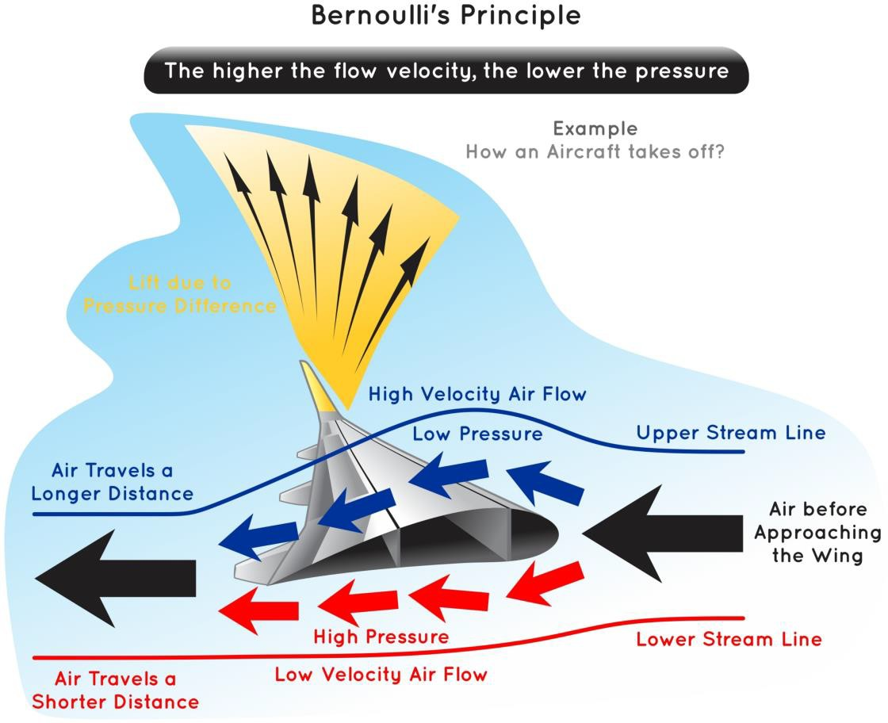

### What is Bernoulli’s Principle?

Bernoulli’s principle helps explain how an aircraft uses its wings to achieve lift. Remember, air is a fluid, which means the wings are cutting through the fluid as they fly through the air. The wings are shaped so that air flows faster over the top of the wing and slower underneath. Fast moving air

creates low pressure while slow moving air creates high pressure. The high air pressure under the wings pushes

the aircraft up through the lower air pressure.

An airplane’s wings

are usually curved at the upper part which causes the wind to rush over the top and speed up. This decreases the air pressure on the top of the wing.

The bottom of the wing is generally flat which causes the air to move in a straighter line, which keeps a consistent lower speed and higher pressure. Since high pressure always moves towards low pressure, the air below the wing pushes upward towards the air above the wing.

The wing, which is in the middle of a plane, is then lifted by the force of the air and this causes the entire plane to lift and travel upwards. The faster the plane moves, the more lift there can be.

Name: 18

Curriculum Connection E.1

### Bernoulli’s Principle

Many inventors and innovators have used Bernoulli’s principle to make popular products that we see and use everyday. Bernoulli’s principle states that when a fluid travels faster, it will have less pressure. Conversely, areas of lower fluid speed will have higher air pressure. The differences in air pressures causes objects and substances to move. This helps explain why wings on a plane move aircrafts and how paint moves out of a paint sprayer.

### Example of Bernoulli’s Principle

We can witness Bernoulli’s principle in the following example:

Using a hairdryer to float a ping-pong ball. If you increase the air pressure under the ball, the ball will lift upwards. The air must meet at the other side of the ball at the same time. This makes the air above the ball move faster and thus, lowers the air pressure than the pressure below the ball.

Fast Air

### Paint Sprayer

A paint sprayer has a reservoir half-filled

with paint. Connected to the reservoir is a tube that has a rubber squeeze end to change the air pressure and a nozzle to spray the paint. When you squeeze the rubber bulb, you are blowing air into the tube. This creates a low-pressure system

inside the sprayer when the high velocity air travels forward.

Low Pressure

High Pressure

When the air pressure inside the sprayer changes to a low-pressure system, the paint in the reservoir from the high-pressure area is pushed up the tube and into the low- pressure system. Then the fast-moving air takes the paint out through the nozzle. The air pressure outside of the paint sprayer will be different than the pressure inside the nozzle, which will also help in moving the paint out of the sprayer.

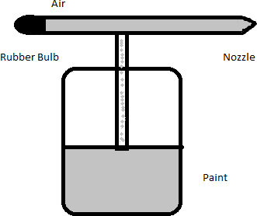

Name: 20

Curriculum Connection E.1

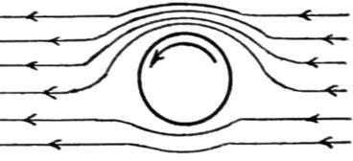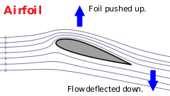

### Two Different Theories of Lift

Sir Isaac Newton and Daniel Bernoulli each have theories of how an aircraft can lift off the ground and how they stay off the ground.

Both theories are commonly used to explain lift and both are debated as the reasons lift occurs. Which one makes more sense to you?

### Achieving Lift – Bernoulli’s Principle

**Lift** is the force that sends an aircraft in the air and also holds it there. Bernoulli’s principle explains how lift occurs when the air pressure under the wing is higher than the air pressure over the wing.

Higher pressure underneath pushes the wing up and produces lift. Looking at the example above, the air must meet at the other side of the ball at the same time. This means the air must move faster over top of the ball then below it. This causes the lower air pressure above and the higher air pressure below.

**Achieving Lift – Newton’s Theory** According to Newton, airplanes fly because their wings deflect air downward so that

the plane is forced upwards. Newton’s third law of motion states that for every action, there is an equal and opposite reaction.

Newton’s law suggests that to generate lift, the wing must divert air down so that the plane can go up. This is done by creating a wing that is shaped to push air under it. The issue is that we need a lot of air to be diverted down in order to generate lift. This is why planes must have an extremely fast takeoff speed as they need to push a lot of air down to lift off the ground.

Name: 22

Curriculum Connection E.2

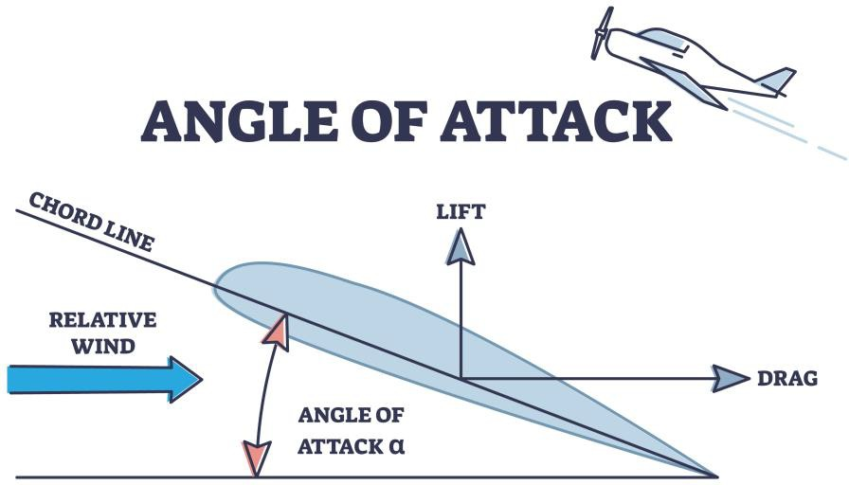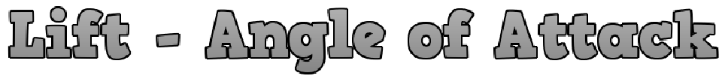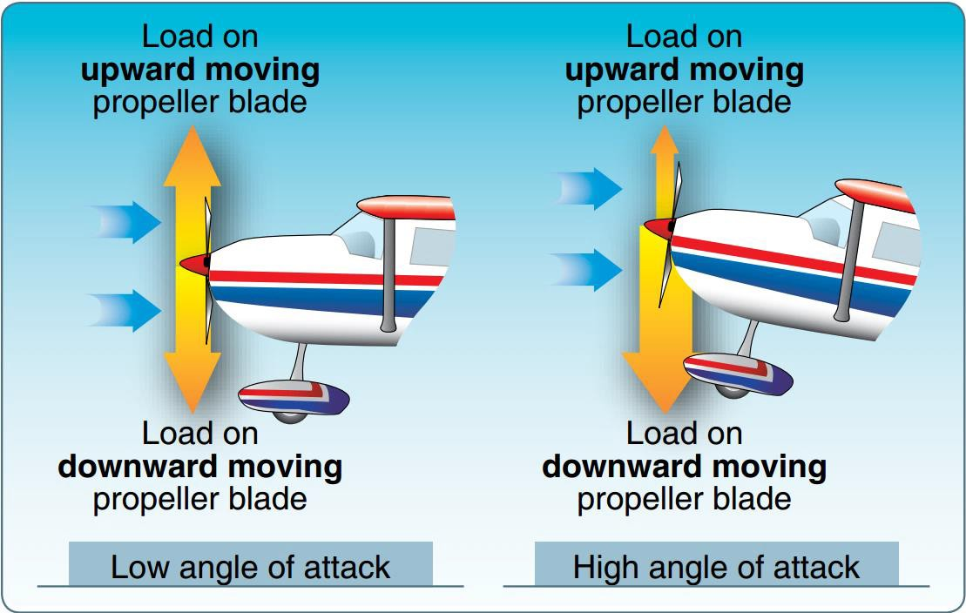

### Angle of Attack

**Angle of attack** is the angle a wing makes with oncoming airflow. Increasing the angle of attack will result in the

plane going upwards and decreasing the angle of attack will lower the plane.

The chord line is the line

from one side of the wing to the

other. The relative wind is the oncoming air that the wings will travel through. With air being a fluid, the plane and its wings are travelling through the air particles.

When an airplane takes off, it travels very fast down the runway. While it is on the ground, its wing angle will be very small, around 3 degrees. After it picks up enough speed, the nose of the airplane will lift off, increasing the angle of attack to around 15 degrees. This will cause liftoff for the airplane.

Once the airplane is in flight at an appropriate altitude, its angle of attack needs to become much less than 15 degrees, or it could stall.

The airplane will settle around 6

degrees while it is in flight.

**Stalling** means the aircraft has lost or reduced its lift because its angle of attack was increased

too much. The angle where an aircraft will stall is called the critical angle of attack. Stalling means air cannot travel above the wing as it strikes the front of the wing causing a lot of drag.

Name: 24

Curriculum Connection E.1

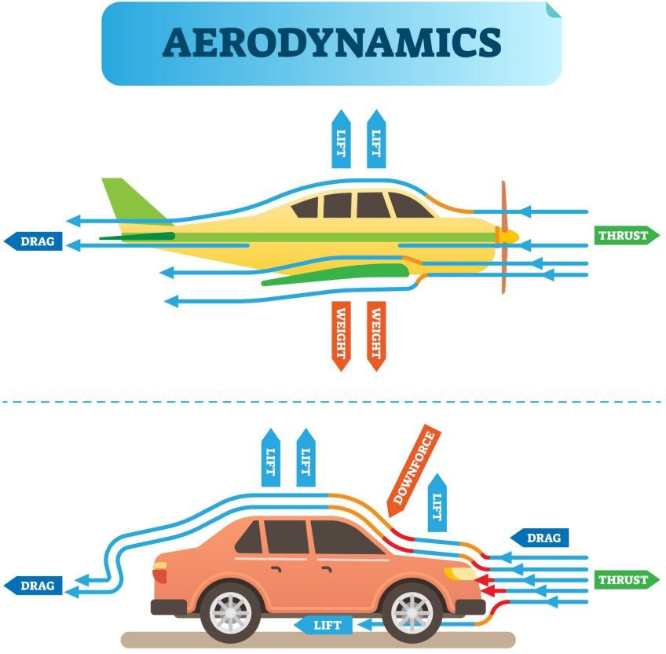

## What is Drag?

Drag in simple terms, is something that slows us down. You can feel drag when you walk in a swimming pool. **Drag** is a force that acts upon an object in the opposite direction that it is moving.

When you stick your hand out of the window of a moving car, it is difficult to move your hand forwards. This is because drag is acting on your hand. You want to move your hand forward, but the drag makes it difficult. You could turn your hand sideways to lessen the amount of drag acting on your hand. This makes your hand more aerodynamic.

## Aerodynamics

The term aerodynamics is commonly

used when discussing drag. **Aerodynamics**

means we make objects that have a shape which reduces the drag from air moving past. Turning your hand sideways when you have it out a car window reduces the drag from the air moving past as the fluid (air) can easily move past the small surface area of your hand. Therefore, we can reduce drag by making aerodynamic planes that cut through the air easier.

All planes have some drag, which makes it important for engineers to calculate the amount of drag an airplane has so they can adjust how much thrust is needed to overcome drag and keep the airplane up in the air.

Engineers have the challenging job of finding creative ways to reduce drag so that airplanes can go faster and fly more efficiently. The less drag an airplane experiences, the less fuel it needs to fly at the same speed.

## Importance of Drag

Drag slows down objects in flight, which is important for regulating speed and landing. Skydivers use drag to slow down their falls so they can land safely. A parachute is another example of a mechanism that produces drag for falling objects to land safely.

Name: 30

Curriculum Connection E.1

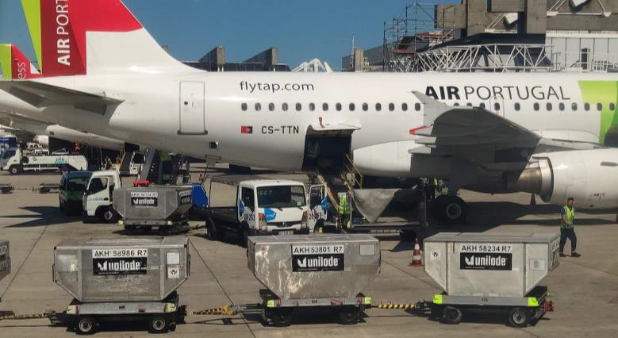

### Effect of Gravity on an Aircraft

**Gravity** is the force of attraction that pulls together all matter. The Earth has a gravitational pull that pulls all matter towards the centre of the earth. This keeps us on the ground and it makes things that are in the air, fall to the ground.

Gravity is the biggest obstacle that makes flying a challenge as humans are not designed to fly. **Weight** is the force of gravity pulling aircrafts to the ground. Lift is what is used to overcome gravity and send an aircraft into the air.

### Centre of Gravity

The centre of gravity (CG) of an aircraft is the point it would be possible to balance the aircraft if we suspended it in air. This means there is an equal weight on all sides of the center of gravity. CG can also be called the balance point, and it is very important to know because it affects the stability and performance of the aircraft.

The CG of an aircraft should be near the centre of lift, otherwise the plane will pitch forward or backwards and would never stabilize. Usually the centre of gravity is near the wings, as the wings are what lift the airplane.

### Effects of Excess Weight on an Aircraft

Too much weight on a plane affects the performance of a plane in many aspects. To make up for the extra weight, a plane needs: a higher takeoff speed, longer runway, lower maximum altitude, shorter range of how far it can go, slower cruising speed, reduced maneuverability, higher approach and landing speed and more.

This is why airlines require passengers to have their bags weighed so they understand how much weight will be onboard the plane. They will also position the suitcases near the wings to keep the extra weight near where lift is achieved. If they put the cargo at the front or back of the plane, it would move the CG away from the wings.

Name: 32

Curriculum Connection E.1

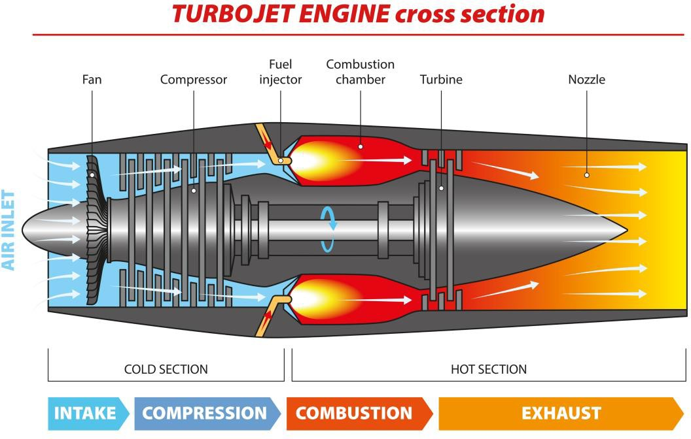

**What is Propulsion? Propulsion** is the force which moves an aircraft through the air. Propulsion is also called thrust.

Thrust is needed to overcome the drag of an airplane and to overcome the weight of a rocket. In aircrafts, thrust is generated by engines.

A **jet engine** is a machine that converts fuel into a powerful pushing force that we call thrust.

Engines create thrust by sucking in air through the front and then having an air compressor raise the pressure of the air. As the pressure rises, the compressed air is then sprayed with fuel by the fuel injector. This creates an electric spark that lights the mixture on fire. The burning gases expand and blast out through the nozzle at the back of the engine. As the exhaust shoots backwards out of the nozzle, the engine and aircraft thrust forwards.

Pilots can accelerate the aircraft by adjusting the thrust. They use a mechanical device to add more fuel to the engine’s system, which creates more exhaust shooting backwards. This causes an equal opposite reaction of propelling the aircraft forwards.

## Propeller

A propeller can generate thrust for aircrafts to fly. A **propeller** has spinning blades that generate differences in air pressure between the front and back surfaces of the blades.

A propeller works the same way as a screw. When you turn a screw into a wall, it goes further in as it grabs the wall and travels further with each turn. A propeller works the same way as it spins with the help of an engine. The blades pull the air (fluid) behind which results in the aircraft being pushed forwards. The more air that is pulled behind the propeller, the more thrust is generated.

Smaller aircrafts will use a propeller on the front to generate thrust. As aircrafts get larger, they require more thrust. These larger aircrafts use multiple jet engines to create this additional thrust needed for long trips with heavy loads.

Name: 36

Curriculum Connection E.2

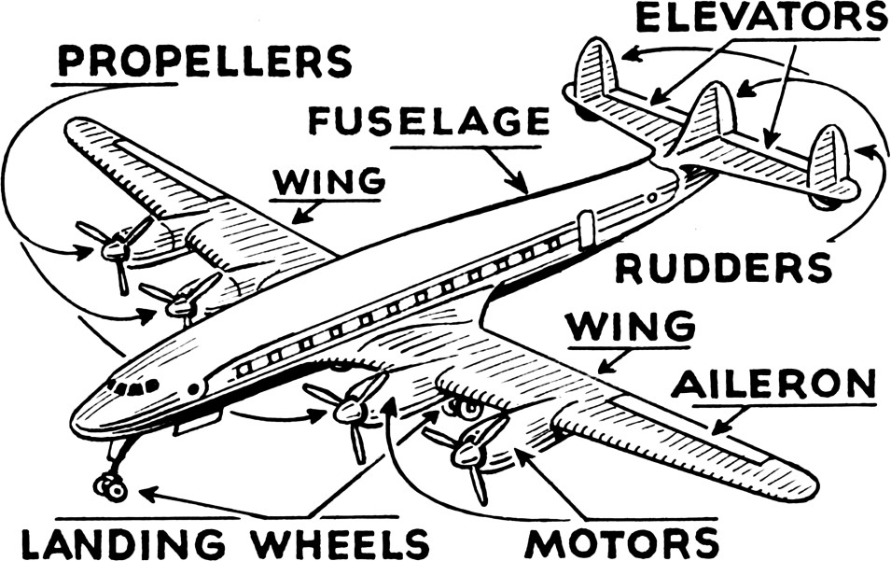

## Vertical Stabilizer

**Horizontal Stabilizer**

|  |  |
| --- | --- |
| **Aircraft Part** | **Function – What It Does** |
| Elevators | Controls the pitch motion of the craft. Pitch means going up or down. When the elevators go up, the aircraft goes down. |
| Rudders | Controls the yaw motion. The yaw motion is the side to side movement of the nose of the craft. |
| Wing | Controls the lift of the plane. A plane needs winds to generate lift off the ground. The wings also keep the plane in the air. |
| Aileron | Controls the lateral balance by moving the aircraft left or right. When the right aileron goes up, the left one goes down. An aircraft can roll using the ailerons. |
| Motor | Controls the thrust to lift the plane into the sky. The motor sends the plane forward |
| Landing Wheels | Allows the plane to land safely |
| Fuselage | The centermost piece of the aircraft that holds the cargo and passengers. Most aircrafts can hold up to 500 passengers and 200,000 pounds of cargo! |
| Propellers | Controls some of the thrust the plane needs to go forwards. Also  controls pitch by tilting the propellers up or down. |
| Horizontal Stabilizer | Helps control pitch. Keeps the aircraft’s equilibrium when flying  up and down |
| Vertical Stabilizer | Helps control yaw by preventing lateral movements of the craft. Needed for complete control of the plane. |

Name: 38

Curriculum Connection E.3

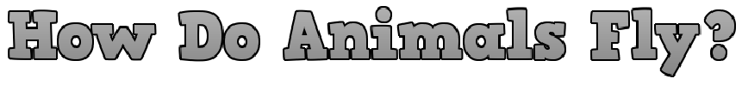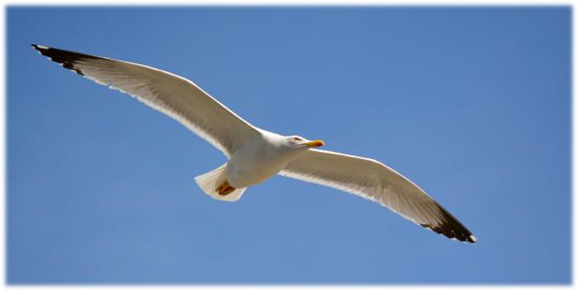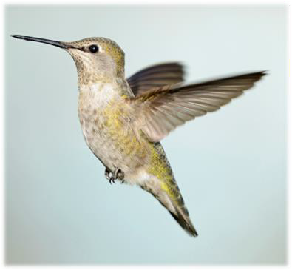

### Flying Animals

The only animals that can truly fly are birds, insects, and bats. Many other animals can glide for a short period of time, but cannot generate lift from the ground. Almost all birds can fly because they have most of the following physical features:

* Lightweight – makes it easier for them to achieve lift
* Light bones – a bird’s bones are almost hollow which makes the bird lighter
* Strong flight muscles that allow the flapping of wings
* Wings that create the force needed for lift
* A streamlined body that reduces the force of drag

### How Birds Fly

A bird will flap its wings to generate lift from the ground. The

curved shape of a bird’s wings allows air to move quickly over

the top surface of the wing, which lowers air pressure on the top. This generates lift as the bird will move into the area of lower air pressure.

The angle of the wing will also be tilted, which deflects air downwards causing an opposite reaction of the wing and body moving upwards.

Larger wings produce more lift than smaller wings. This means that smaller birds with smaller wings will need to flap more to generate the same amount of lift. Humming- birds are tiny birds that will flap their wings up to 80 times per second, especially if they are just hovering. This is because they cannot glide while hovering.

### Gliding

When a bird is gliding, it is not working at all. Its wings are open to its sides cutting through the air at a slight angle, which deflects the air downwards causing the body to move or stay

upwards. As drag acts on their body, they will lose some lift and will need to increase their wings angle of attack so they can fly upwards.

Name: 40

Curriculum Connection E.3

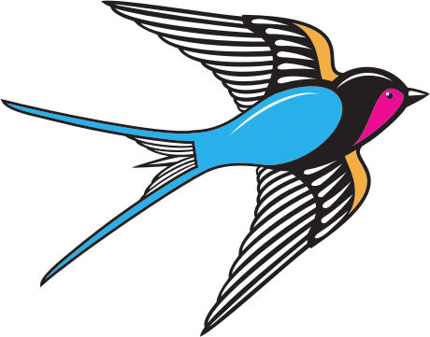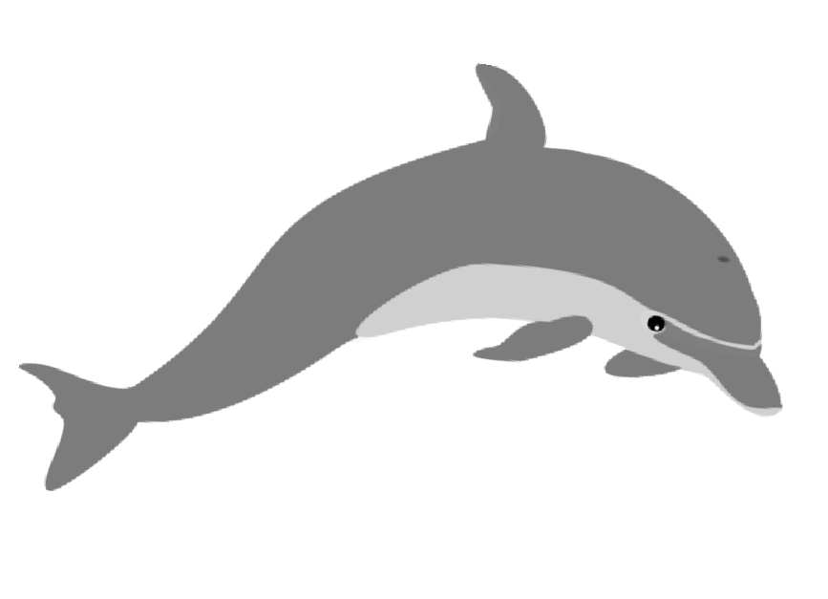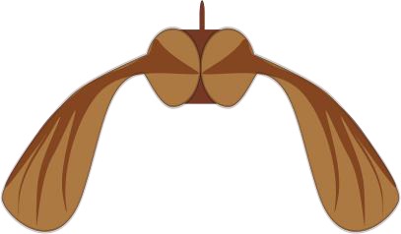

### Animal Adaptations

Animals need to adapt to be able to survive in their environment. Adapting means they need to change. Therefore, **animal adaptations** are the changes in animals that allow them to survive in their environment. Dolphins and birds have

adapted to give them the ability to propel themselves through water and air.

### Dolphins and Barn Swallows

Dolphins and barn swallows have streamlined bodies that are shaped to reduce air resistance when they are in motion. **Air resistance** is also known as drag, which is the force of air pushing on any object that passes through it. Both dolphins and barn swallows have teardrop shaped bodies that reduce drag in water and air.

**Friction drag** happens when two things rub together. A flat faced organism will feel more friction drag when moving through the air or the water. The flat shape

has a large surface area that the air strikes and has to travel relatively further distances to pass by it. Adapted animals like swallows and dolphins have less friction drag

acting against them, which allows them to move easier in the fluid they live in.

### Helicopter Motion

Maple trees drop their seeds in helicopter shaped “samaras”. The maple tree plant has adapted to dropping these helicopter seeds to ensure that their seeds will be spread near and far from the plant they fell from. The seed falls in a helicopter motion as it has wings attached to the seed.

As a result, when the seed falls, it spins as the wings cut through the air. The wings have a wider side and a narrower side that make them spin due to Bernoulli’s principle.

Name: 42

Curriculum Connection E.3

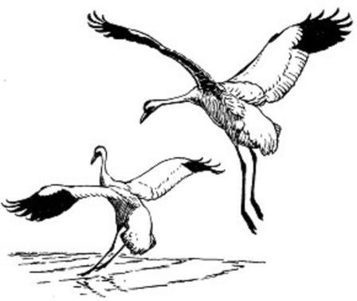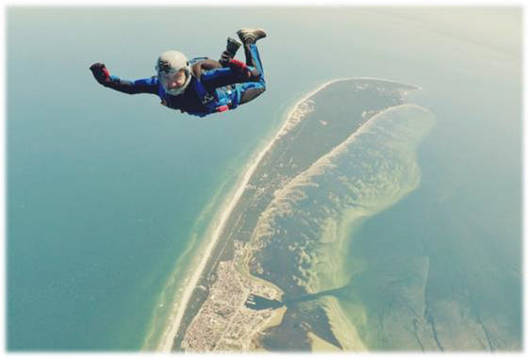

### Adapting Drag Using Design Features

Drag is not always a bad thing as it helps things slow down when they are travelling at high speeds. Airplanes and birds both fly and both are designed to decrease drag. However, both need to be able

to increase drag in order to slow down to land safely.

### Increasing Drag

An airplane will increase the drag of air flow over its wings by using flaps. If you’ve ever looked at an airplane wing closely, you will see flaps on both wings that are usually down when the plane is flying or taking off. But when it is time to slow down for landing, these flaps will open up, which makes the air rub against the flaps and slow the airplane down. With the flaps open, the plane is less aerodynamic, as it has more surface area for the air to hit and resist.

A bird will also use its wings to increase drag. They don’t have flaps on their wings, but they do have the capability to open their wings up. When birds are landing, they will increase the drag on their bodies by opening their wings, which makes them less aerodynamic when flying through the air.

Skydivers will also increase the amount of drag they have by using their arms. When they want to increase the drag on their bodies, they open their arms and spread their legs to make them as big as possible.

With a larger surface area, they create more drag and

a slower, more enjoyable fall. Opening a parachute will increase the drag even more because the surface area is larger. This creates more air resistance and a much slower fall.

### Decreasing Drag

Airplanes are made aerodynamically and will close their flaps to decrease drag. A bird is unique because they will tuck their wings when they are diving from high altitudes to lower altitudes to find prey. This decreases drag as they cut right through the air.

Name: 44

Curriculum Connection E.3

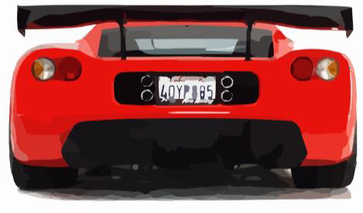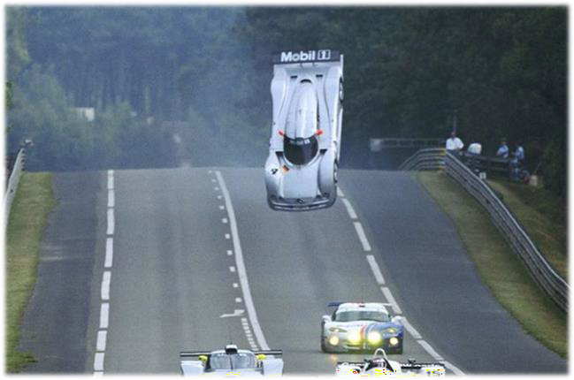

### Design Features – Race Cars

For most vehicles, lift isn’t an issue because of the shape and speed of the vehicles. The average vehicle has an aerodynamic shape, but also a heavy weight. The heavy weight comes from the vehicle parts, like the engine, but also from the seats and consoles. The larger the vehicle, the more weight it will have, meaning lift won’t be an issue.

Race cars on the other hand are designed for speed. They are lightweight so their engine can thrust it forwards as fast as possible. They are also aerodynamic, so that drag can be reduced and thrust can be maximized.

The problem is that with too much thrust and not enough drag, lift can become a problem. Race cars need to be designed to reduce lift because they need the car to stay on the ground. If the car lifts off the ground, the friction that causes the tires to spin is no longer working. That is why race cars use a spoiler.

### Car Spoiler – How They Work

A **spoiler** is a ramp shaped wing that goes on the back of a vehicle to change the air pressure and keep the back of

the vehicle from lifting off. As a car moves forward, air flows across the body. At the front, the air flows smoothly, but at the back, it becomes turbulent and chaotic.

The difference in air pressure in the back will increase the lift of a vehicle. When a spoiler is used, the air hits the spoiler and pressure builds up on top which causes the car to be pushed down. This increases the drag of the car which can slow it down, but it’s better to have

a bit more drag than any lift.

Today, we see many car enthusiasts use spoilers on their car for decorative purposes. They do not need a spoiler as they are likely not travelling fast enough to create the air pressure conditions that will generate lift in the back of the vehicle.

Name: 48

Curriculum Connection E.3

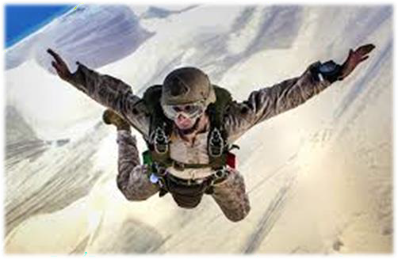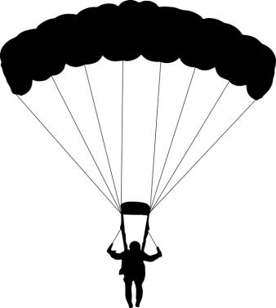

### What is a Parachute?

A **parachute** is a device that is used to slow down an object that is

falling towards the ground. When someone goes skydiving, they use a parachute to counter the force of gravity pulling the person to the ground. Gravity is the force that pulls all matter to the centre of the earth.

### Why Use a Parachute

We can use a parachute to slow down the force of gravity. We do this by increasing another force, which is air resistance. When we fall to the ground, our body shape and aerodynamics will have some drag that slows the force of gravity. If you are skydiving, you can open up your body in a starfish position to increase your air resistance. This will slow you down by increasing drag and countering the force of gravity.

Gravity will be too strong if all you do is fall with your belly facing the earth. In fact, skydivers travel at approximately 200 km/h in this position. They travel upwards of 290 km/h when in a diving position with their heads first.

In order to slow the force of gravity, we can use a parachute to increase the wind resistance. When using an open parachute, the skydiver will slow to 28 km/h, which allows them to hit the ground safely.

### How a Parachute Works

A parachute works the same way that our bodies work when we starfish while falling. Parachutes provide more surface area for a falling object or person to use to increase the air resistance while falling. Remember, there is gas all around us. It is a fluid that we travel through. When we increase our surface area that needs to travel through the air, we create more air resistance and this slows us down or makes it harder to travel through.

Imagine running your hand through water. When you slice through the water with your hand, it is easier to move your hand quickly, but when you open your hand up and move it through the water, there is more resistance, and it is slower. Water and air are both fluids and the same principles apply.

Name: 53

Curriculum Connection E.3

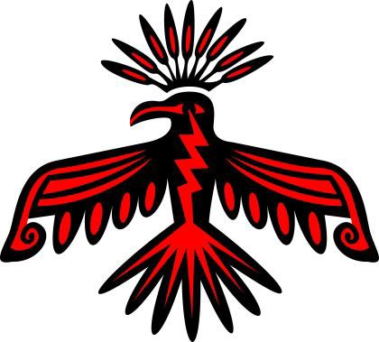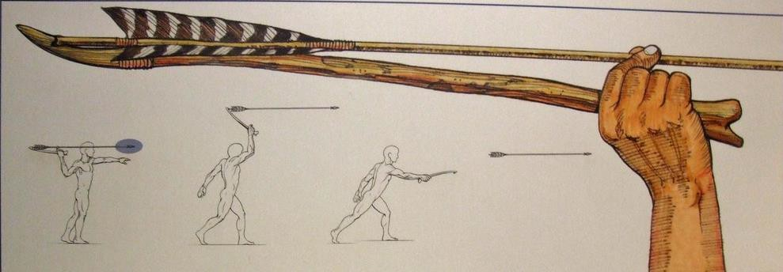

### First Nations and Métis Art and Storytelling - Birds

First Nations and Métis cultures deeply appreciate and respect nature, including birds.

Birds are often chosen as symbols in these cultures due to their unique qualities that align with cultural beliefs and values. Birds' ability to

fly high and close to the sky often associates them with the spiritual realm or the connection between the earth and the heavens.

For example, the Thunderbird, often seen in art, is a powerful, sacred being in many of these cultures, representing

not just the physical bird but also the elemental power of thunder and

storm. Ravens, common in Northwest Coast art, are known as tricksters and creators,

reflecting the intelligent and often mysterious behaviour observed in these birds in nature.

### The Role of Birds in Storytelling

Birds also play a central role in Indigenous storytelling. These stories passed down generations carry lessons and moral teachings. In Ojibwe culture, there's a story about how a small bird, the chickadee, shows bravery, suggesting that size does not determine courage. This story teaches that each creature has its own strength and value.

### Technologies Using Flight

First Nations and Métis people have a long history of crafting tools that cleverly use the principles of flight.

The atlatl and the bow and arrow are

remarkable examples. Both of these hunting tools were designed with a deep understanding of aerodynamics.

The atlatl, a spear-throwing device, increases the speed and distance of a dart by extending the arm's length, acting like an extra joint. Similarly, the bow and arrow, with its aerodynamic shape and fletching, follows a stable, accurate trajectory towards its target.

Name: 61

Curriculum Connection CS.1

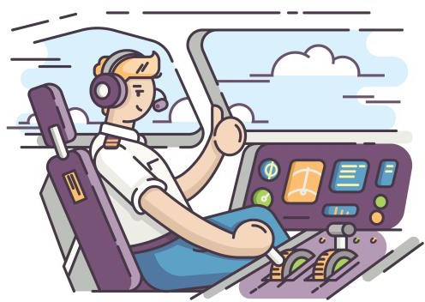

### Auto-Pilot

Planes today are built to fly themselves. The reason is because most plane crashes are a result of human error. Auto-pilot is used for cruising at altitude, while pilots taxi the airplane to the runway, land the plane, and perform take offs.

### How Does Autopilot Work?

A computer system monitors all sensors and components of the airplane through feedback loops. The computer is constantly sending and receiving if/else statements throughout the flight.

For example

|  |  |  |  |
| --- | --- | --- | --- |
| Is the | right wing | | balanced |
| if the right wing is not balanced | | else | |
| then balance the wing | | continue flying | |

The autopilot works to monitor speed, steering, altitude, and more. All of this is done without the pilot lifting a finger.

### Pilots Role

The pilot’s job is to monitor the autopilot system closely to ensure no issues arise. Pilots need to stay alert at all times. They can correct or disengage autopilot if it’s glitchy, or in order to perform a manual landing.

As of 2022, pilots perform 99% of landings, although autopilot can perform the landings as well. In cases where visibility is an issue, autopilot can land the planes safely.

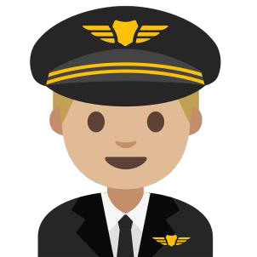When a plane is being flown by a pilot, passengers will notice the ride will be bumpier. This is because a computer can fly more efficiently than humans. Computers can perform tasks quickly and gradually so that the passenger doesn’t feel the plane’s movement. For example, after a gust of wind, a plane’s angle might be off.

A pilot will likely take 30 seconds to level the plane. Autopilot can level the plane is 15 seconds, about half of the time.

### Future For Pilots

So, will pilots be needed in the future? Yes, pilots will always be needed to monitor the autopilot program. However, the job is changing. No longer are pilots only required to fly a plane.

Today, pilots need to also understand coding and more science and technology as they have to understand how autopilot works so they can troubleshoot problems that could arise.

Name: 66

Curriculum Connection E.4

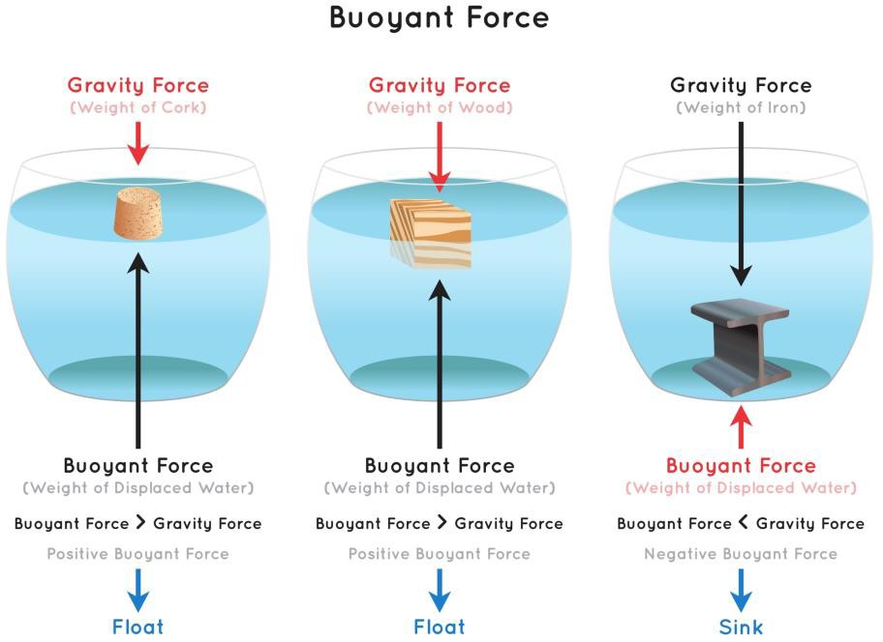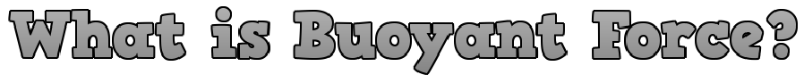

**Understanding Buoyant Force** Buoyant force is a fascinating force that becomes evident when an object is submerged in a fluid, such as water or air.

Have you ever noticed how much lighter you feel when you jump into a pool? That's the buoyant force! It's the upward push exerted by the fluid on the object, opposing the pull of gravity.

### Floating: The Victory of Buoyancy Over Gravity

An object floats when the buoyant force overpowers the pull of gravity. In simpler terms, if the fluid pushes upward on an object with more force than gravity can pull it down, the object will float. Gravity pulls harder on dense or heavy objects.

Examples of this are a rubber duck in a bathtub or a log floating in a river. They're less dense than the water they're in, so the buoyant force from the water pushing upward is stronger than the force of gravity pulling down.

### Sinking: When Gravity Wins the Battle

Conversely, if an object sinks, it means that the pull of gravity is stronger than the buoyant force. This implies that the object is too dense for the fluid to hold up. The force of gravity acting on the object is stronger than the fluid's push, causing the object to sink.

Think about a pebble or a coin - when you toss them into a pond, they sink to the bottom. They're denser than the amount of water they displace, so gravity's pull on these objects is stronger than the buoyant force of the water.

Name: 68

Curriculum Connection E.4

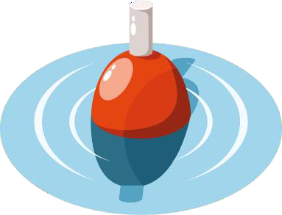

### The Importance of Density

To understand why some things float and some sink, we must talk about 'density.' Density is a measure of how tightly packed the 'stuff' or 'matter' in an object is. If you have a fluffy marshmallow and a small rock of the same size, the rock is denser

because it has more matter packed in the same space. We measure density in grams per cubic centimeter (g/cm³).

### Density and Buoyancy in Harmony

If an object is less dense than the fluid it's in, it floats. Take a rubber duck, for instance. It has a density less than 1 g/cm³, while the density of water is about 1 g/cm³. Because the rubber duck is less dense than water, it floats!

But if an object is denser than the fluid it's in, it sinks. A steel marble, with a density of around 8 g/cm³, is denser than water. That means when you drop it into a pool, it sinks! And fluids are not just liquids; air is a fluid too! A helium balloon is a great example.

The density of air is about 0.0013 g/cm³, while the density of helium is only about 0.00018

g/cm³. Because the helium balloon is less dense than the air, it floats upwards.

### Fluid Densities and Their Impact on Buoyancy

Each fluid, be it a liquid or gas, has a specific density. This density decides the strength of the buoyant force it can exert. Essentially, denser fluids can support denser objects.

Take water, for example, with a density of about 1 g/cm³.

If you drop a metal paperclip (density: 7.8 g/cm³) into it, the paperclip will sink because it's denser than the water.

However, if you put the same paperclip into mercury, a very dense liquid with a density of approximately 13.6 g/cm³, it would float! The mercury's high density provides a strong enough buoyant force to support the paperclip.

Name: 74

Curriculum Connection E.4

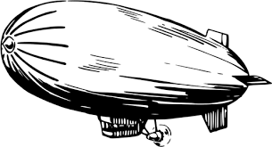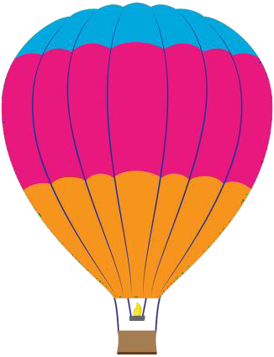

### Lighter-Than-Air Flying Devices

A **lighter-than-air flying device** is an airship that generates lift because they use gases that are lighter than air. Most commonly, these airships use helium as the gas because its density is significantly less than air, and it is cheaper to buy than other gases.

### How Airships Work – Helium Balloons

An airship controls its flying altitude the same way a submarine does, through buoyancy. Buoyancy is the ability to float. Airships use helium to fill their ballonets, making the air in these huge holding tanks less dense than the air outside of them. When the air is less dense, it rises above the air in the atmosphere that is heavier. This makes the airship positively buoyant and means it will rise.

When the pilot needs to go up, they add helium to the ballonet. When they need to go down, they pump air into the ballonet to make them negatively buoyant. When they are at a cruising altitude, they balance the amount of air and helium in the ballonet to stay at

the same altitude.

### Hot Air Balloons

A hot air balloon is another lighter-than-air flying device that uses the same principle as the helium airships. They both need the air in the balloon to be less dense than the air outside of the balloon. This allows them to achieve buoyancy in the air, which gives them lift.

A hot air balloon uses heated air inside the balloon. Heated air is less dense than the surrounding air in the atmosphere. This is because when air is warmed, the molecules move faster and further apart. This causes the warmer air to expand and spread out, making it less dense. To go up in a hot air balloon, the pilot will heat the air using a torch. To go down, the pilot stops heating the air, which causes the air to cool.

Name: 77

Curriculum Connection E.5

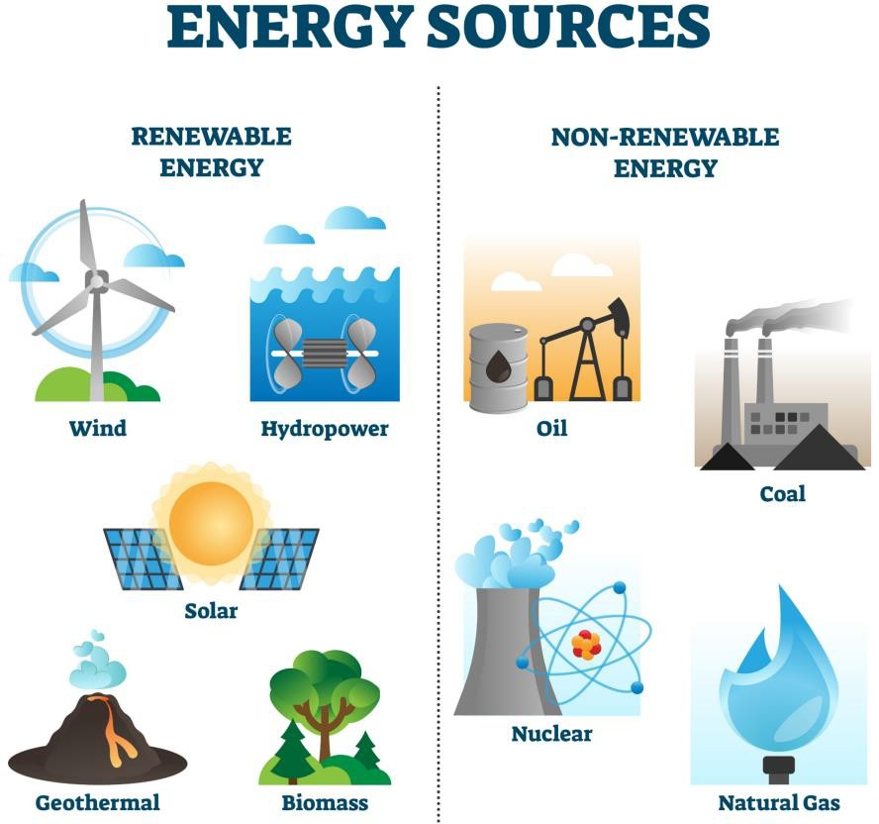

### Non-Renewable Resources

**Non-renewable resources** are resources that will not replenish themselves in a lifetime. Once we use all of a

non-renewable resource, it could take billions of years to form again.

**Nuclear power** uses uranium that is a non-renewable resource. **Fossil Fuels** like coal, oil and natural gas are non-renewable resources that are found by digging deep into the ground. Once these materials are all used up, they can not be used again. These resources are easy to use and provide an efficient form of energy, however they are dangerous to our environment.

Using these non-renewable resources involves heating up the

material which produces a by-product that pollutes our environment. Scientists are searching for more effective ways to use renewable resources. These non-renewable energy sources are expected to run out very soon if we do not change the way we live.

### Renewable Resources

A **Renewable resource** can be used over and over again without any effect on the environment. The sun produces enough **solar energy** for the entire population of the world. If we could setup enough solar panels to collect the energy, we could solve the non-renewable energy crisis. The problem is that the sun is not always shining where these solar panels are located, which makes it an inefficient means of energy.

**Wind energy** is also a renewable resource as the wind will always come and go, but that is the problem. The inconsistent flow of the wind makes it another inefficient source of energy.

**Water** or **hydro energy** uses the flow of water through a dam to generate energy.

Water power is efficient but costly to build the dams necessary.

**Geothermal energy** uses the heat from below the Earth’s surface to produce steam

that spins turbines and generates power. These setups are efficient but also costly.

The last renewable resource that is commonly used is biomass. **Biomass** energy comes from burning plants, crops, and animal waste to create heat and steam that spins turbines.

Name: 79

Curriculum Connection E.6

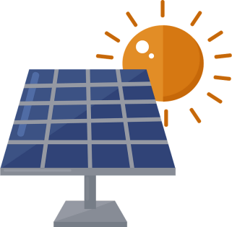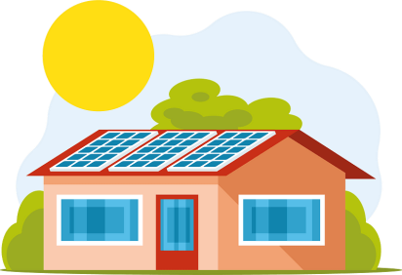

### What is Solar Energy?

**Solar energy** is energy given off by the sun’s rays. The sun has been providing humans with solar energy for thousands of years. The sun has given us thermal energy to keep us warm and dry our clothes, and light energy to allow us to see.

As technologies advance, humans are now using solar energy to create electricity. Using solar energy for electricity means the sun is powering our electronics, machines, electric cars and more.

Solar energy is a renewable energy source because we cannot

use it up. It is an **infinite** resource, meaning the supply is endless.

### How Solar Energy Works

Solar energy is harnessed by solar panels that collect and store

the sun’s energy. The stored energy is potential energy to be used on demand. Solar

panels are made of many solar cells that are all connected.

The solar cells have two sides. One side has electrons that are positively charged and the other side has a negative charge. When the sunlight strikes the solar cell, the energy knocks the electrons loose and they begin to flow from one side to the other, creating an electrical circuit. We can plug our electronics into a solar panel so that the flowing electrons can give them power.

### Benefits and Drawbacks to Solar Energy

|  |  |
| --- | --- |
| **Benefits** | **Drawbacks** |
| Renewable energy we won’t run out of | Solar energy can only be collected when it is sunny. Cloudy, rainy days will slow down energy storage |
| No greenhouse gases (no air pollution) | Batteries store the solar energy. Batteries don’t decompose, meaning they will end up in landfills when they no longer work |
| Once setup in homes, the cost is free to use electricity | It costs a lot to install solar panels |

Name: 81

Curriculum Connection E.6

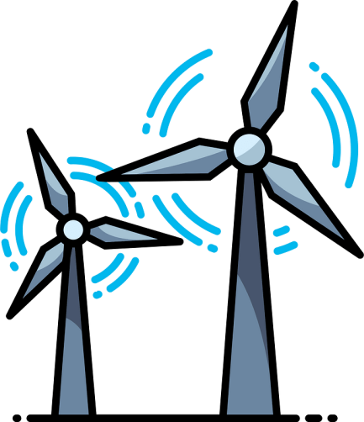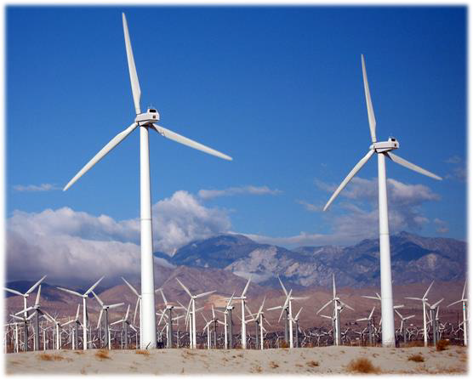

### What is Wind Energy?

Wind is the movement of air from areas of high-pressure to areas of low pressure. When the gases that make up our air are warmed, they spread out and have higher

pressure. When the air is cooled, the pressure is lower as the gas particles get closer together.

**Wind energy** is the energy we harness from the movement of the wind. Wind energy can fly a kite, move a sailboat, and

spin a wind turbine. When we use a wind turbine, we can use wind energy to create electricity.

### What is a Wind Turbine?

A wind turbine is like a windmill. When a wind turbine is spun by wind energy, the turbine connects to a generator that converts the mechanical energy into electrical energy by forcing the electrons through an electrical circuit.

### Use of Wind Energy in Canada

Wind energy is the second most used renewable energy source in Canada. It creates 3.5% of Canada’s electricity. Moving water is number one, with 59% of Canada’s electricity generation.

**Benefits and Drawbacks of Wind Energy**

|  |  |
| --- | --- |
| **Benefits** | * Clean energy that doesn’t produce greenhouse gases and won’t run out * Free energy once you have setup the wind turbine * Wind turbines don’t take up much space on the ground |
| **Drawbacks** | * Dangerous to birds and bats who can fly into the blades * They are noisy so they are usually built in rural areas * Are expensive to setup * They only work when the wind is blowing. This causes unpredictable amounts of energy. If it isn’t windy for a long period of time, the stored wind energy will run out |