**First Nations, Metis and Inuit Traditional Knowledge**

First Nations, Métis, and Inuit communities across Canada have long used traditional knowledge and observational skills to understand and predict the weather in the regions where they lived. Their knowledge systems are deeply rooted in the environment, passed down through generations, and involve an intimate understanding of natural phenomena. Here are some ways these communities traditionally predicted and understood the weather:

**Observation of Natural Signs**

* **Animal Behavior**: Many Indigenous groups observed the behavior of animals as indicators of upcoming weather changes. For example, the migration patterns of birds, the activity levels of insects, and the behavior of animals like wolves or deer were considered reliable weather predictors.
* **Plant Behavior**: The growth and blooming patterns of plants, the movement of certain seeds, or the timing of flower blooms were indicators of seasonal changes. For example, the early or late blooming of specific flowers could signal whether a season would be warmer or colder than usual.
* **Sky Observations**: Changes in the appearance of the sky, such as the colors at sunrise or sunset, the movement of clouds, or the appearance of certain celestial bodies (like the moon or stars), were used to forecast the weather.
  + The **Métis** and other groups in the Prairie provinces were particularly attuned to the sky and its changes, using the positions of the sun and moon to determine seasonal shifts.

**Physical Signs in Nature**

* **Ice and Snow Patterns**: Inuit, particularly in the Arctic regions, paid close attention to ice formation and snow conditions to predict the weather. The thickness of sea ice or the patterns in snowdrifts could indicate whether the winter would be long and harsh or milder.
* **Wind**: The direction and strength of the wind were key indicators of weather patterns. For example, winds from the east were often seen as bringing snow, while winds from the west might signal clear weather. Inuit and other communities relied on these observations to predict storms or fair weather.
* **Water Levels**: Many First Nations in the Pacific Northwest, such as the Haida, observed the behavior of rivers, lakes, and coastal waters. High water levels in rivers could signal heavy rain or snow in the mountains, which would lead to flooding or changes in travel conditions.

**Storytelling and Cultural Practices**

* **Oral Traditions and Myths**: Weather knowledge was often passed down through storytelling. Myths and legends explained the relationships between humans and nature, including weather patterns. These stories might include tales of spirits or deities influencing the weather, providing symbolic knowledge about seasons, storms, and changes in climate.
* **Ceremonies**: Certain ceremonies and rituals were performed to ensure favorable weather conditions, such as good harvests or hunting conditions. In some communities, specific prayers or dances were conducted to ask for good weather or to prepare for the arrival of storms.

**Celestial and Astronomical Knowledge**

* **Tracking the Moon and Stars**: The lunar cycle played an important role in understanding the seasons. The Inuit, for example, had a detailed system of moon phases, which were directly linked to the changing weather. In many Indigenous cultures, the stars were also used to predict weather patterns. The **Métis** used the stars to determine the optimal times for hunting and other activities, relying on the celestial bodies to guide their seasonal activities.
* **Eclipses and Halos**: Solar and lunar eclipses, along with the appearance of halos around the sun or moon, were seen as significant weather omens. Some communities believed that these phenomena were a sign of significant shifts in the weather, such as upcoming storms or changes in the season.

**Long-Term Patterns and Seasonal Cycles**

* Indigenous communities had a deep understanding of long-term weather cycles and how they affected the land over years or decades. They observed recurring patterns in the migration of animals, plant growth, and weather changes that helped them prepare for the next cycle. The Inuit, for example, used patterns of sea ice and weather over many years to track climate trends and predict future conditions, while First Nations across the country followed seasonal migrations of animals like caribou, bison, and salmon.
* **First Nations of the Plains**: The Plains Indigenous groups, like the Cree and Assiniboine, were known to track seasonal changes and variations in the weather through animal and plant behavior, along with observations of environmental conditions such as wind, cloud cover, and temperature shifts. These communities often developed weather predictions based on long-term ecological cycles.

**Local Knowledge and Regional Variations**

* **Inuit and Coastal Knowledge**: The Inuit of the Arctic were experts in predicting sea ice conditions, vital for hunting and travel. They closely observed the timing of ice freeze and break-up patterns, understanding how these shifts correlated with seasonal weather and changes in animal movement.
* **Forest and Mountain Communities**: Indigenous groups living in forested or mountainous areas, such as the Algonquin or the Dene, were keen observers of the wind, cloud patterns, and physical signs in the landscape. They used knowledge of snow conditions and the behavior of forest creatures to anticipate weather changes, crucial for their survival.

**Conclusion**

Traditional knowledge about weather was a blend of practical observations, deep spiritual connections to nature, and long-term ecological understanding. This knowledge enabled Indigenous peoples to survive and thrive in diverse and often harsh environments. Today, many Indigenous communities continue to use and share this traditional knowledge, and it is increasingly recognized for its value in climate science and environmental management.

## Understanding Climate Observations

First Nations, Métis, and Inuit peoples have lived in harmony with the land for thousands of years. They have keenly observed changes in weather and climate over generations. These observations, passed down through stories and traditional practices, can offer unique and localized knowledge about the climate.

## Climate Stories From Our Elders

Our elders are the keepers of knowledge. They share stories about the weather patterns they have witnessed. These stories can tell us about longer-term changes in the climate. It might be a tale about a lake that used to freeze solid in winter but now remains partially unfrozen. Or a story about how certain plants flower earlier in the year than they used to.

## Anemone clipartThe Value of Indigenous Observations

Indigenous observations of climate offer a wealth of information that scientists can learn from. For example, they may notice shifts in animal migration patterns or changes in when certain plants bloom. This information can provide a local context to the climate data collected by scientists.

## Examples of Indigenous Observations

* Ice Freeze and Thaw Times: Lakes and rivers freeze later and thaw earlier.
* Animal Migration Patterns: Migratory animals change their timing or routes.
* Timing of Plant Blooming: Certain plants bloom earlier or later than usual.
* Seasons: The timing and length of the seasons are changing.

## Weather Forecasting

Weather forecasting is how we predict what the weather will be like. People have been doing this for a long time and in many different ways. Read about some historical methods for forecasting the weather.

## Historical Methods

People in ancient times had to look at nature to predict the weather.

## Observation

Many ancient people used their senses to observe the world around them. They looked at the sky, felt the wind, and smelled the air to predict what the weather might do.

 Strengths: This method was simple and didn't require any special tools.

 Limitations: The predictions weren't always accurate and could only predict the weather for a short time ahead.

## Animal Behaviour

Some people watched animals for signs of weather changes. For example, birds often fly lower before a storm. More examples include that frogs croak louder and more often before it rains and ants build their mounds higher before it rains.

 Strengths: It's a natural way of predicting weather and often accurate for short- term forecasts.

 Limitations: It isn't precise, and animals can behave differently for reasons other than weather.

## Weather Lore

This includes sayings like "Red sky at night, sailor’s delight. Red sky at morning, sailors take warning." They're based on years of observation.

 Strengths: Easy to remember and sometimes accurate.

 Limitations: These sayings aren't always correct, and they can be too simple for complex weather patterns.

## Weather Sayings: Do They Really Predict the Weather?

Have you ever heard old sayings about the weather? They're fun to remember and share, and sometimes, they even have a bit of truth in them! Here are some common weather sayings and what they mean:

* "Red sky at night, sailor's delight; Red sky in morning, sailors take warning." This saying means that a red sky at sunset could suggest a high-pressure system (good weather) is coming, while a red sky at sunrise might mean the high-pressure system has already moved east, and a low-pressure

system (bad weather) might be following.

* "Rainbow in the morning gives you fair warning." A morning rainbow in the west means rain could be coming, as weather usually moves from west to east.
* "When dew is on the grass, rain will never come to pass."

Dew forms when the night is clear and cool, conditions that often lead to a sunny day.

* "Clear moon, frost soon."

A clear sky allows heat to escape into space, which can cause cooler temperatures and frost.

* "If the rooster crows on going to bed, you may rise with a watery head." Roosters crowing at night could suggest an approaching weather change, perhaps bringing rain.
* "When the stars begin to huddle, the earth will soon become a puddle."

A halo around the moon, making stars seem to huddle together, can suggest rain is on the way.

* "When leaves show their undersides, be very sure rain betides."

Leaves often flip over when it's windy, which can sometimes mean a storm is

coming.

* "A ring around the sun or moon, means rain or snow coming soon."

This ring, or halo, is caused by ice crystals in high clouds—a sign of approaching weather fronts that might bring rain or snow.

## Current Methods

Today, we use technology and science to predict the weather.

## Weather Stations

Weather stations are places where we measure temperature, wind speed, and other weather elements. There are thousands of these stations around the world.

In Alberta, Environment Canada operates lots of weather stations. Some of these stations are in places like Edmonton, Calgary, Red Deer, and Lethbridge, plus many more.

 Strengths: They provide precise data that helps us understand the current weather and predict future weather.

 Limitations: They can't measure every spot on Earth, so there might be gaps in our knowledge.

## Satellites

Satellites are machines that we send into space to orbit around the Earth. They have special cameras and instruments to take pictures and collect data about the Earth's atmosphere, the layer of air that surrounds our planet.

 Strengths: They can see large parts of the Earth, even over the ocean or unpopulated areas where there are no weather stations.

 Limitations: They can't measure everything, especially things close to the ground.

## Computer Models

Computers take all the data we collect and use it to predict what the weather will do. They use complex algorithms with their supercomputing power to make accurate predictions.

 Strengths: They can handle a lot of information and can predict the weather for several days ahead.

 Limitations: They aren't always right, especially for longer-term forecasts.

So, weather prediction has changed a lot over time. From watching animals and looking at the sky, we now use satellites and computers.

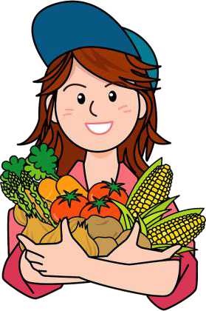**Farming In Alberta**

### Climate's Role in Alberta Farming

Climate plays a big role in farming in Alberta. Check out below how farmers need to understand their climate in order to have their best growing season.

### Crop Type - Picking the Best Plants

The weather in Alberta helps farmers decide which plants to grow.

Because it's usually cool and dry here, they often choose plants like canola, wheat, and barley. These plants are tough and can handle our weather. But, if it gets too hot or dry, like during the big drought in 2002, these plants might have a hard time growing.

### Crop Production - Growing Lots of Food

The amount of food a farmer can grow depends on the weather. Too much rain can cause floods that hurt the plants. If it's too dry, the ground can get too hard for plants to grow. This is what happened in the summers of 2015 and 2018. It was so dry that less food was grown.

### Soil Quality - Taking Care of the Soil

Good soil is important for growing plants. But bad weather can hurt the soil. Heavy rain, for example, can cause soil erosion, which is when soil washes away the top layer of soil. This layer has all the nutrients that plants need to grow. If it's gone, it can be harder for the plants to grow.

### Water Access - Giving Plants Water

Farmers need to make sure their plants get enough water. But the weather can sometimes make this hard. During dry times, there might not be enough water for the plants. If there's too much rain, it can cause floods that can also hurt the plants.

### What is Conservation Agriculture?

Conservation agriculture is a way of farming that takes really good care of the Earth. It is a special way of farming that uses different methods to grow crops without harming the soil or environment.

### Three Important Principles

1. No Soil Disturbance: Farmers try not to disturb the soil too much. This means they avoid tilling (turning over the soil) because it can harm the tiny creatures living in the soil that help plants grow.
2. 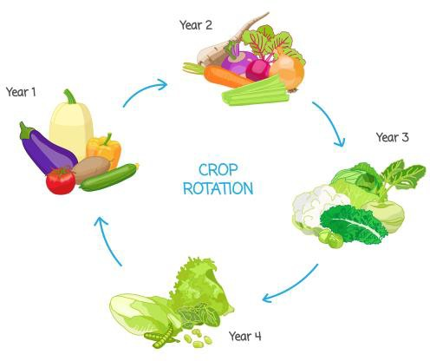Plant Cover: Farmers always make sure there's something growing on the soil. This could be the main crop, like corn or wheat, or a

cover crop that helps keep the soil healthy when the main crop isn't growing.

1. Crop Rotation: This means changing what crop is grown in a field each year. So, one year a farmer might

grow corn, and the next year they might grow soybeans.

This helps keep the soil healthy and stops pests from becoming a big problem.

### Responding to Local Climate

One of the coolest parts of conservation agriculture is how it changes depending on the local climate and weather. For example, in dry areas, farmers might use special techniques to keep as much water in the soil as possible. In places where heavy rain is common, they might plant certain crops that help prevent soil from washing away.

### Why is it Important?

Conservation agriculture helps protect our environment and makes farming more sustainable. This means it can keep going for many years without running out of resources or harming the Earth.

# What is Crop Rotation?

**Crop rotation** is the planned order of growing different crops year after year to get better results. If you grow the same crop every year, you will have problems with:

* Weeds – weeds will grow out of control because their environment is stable
* 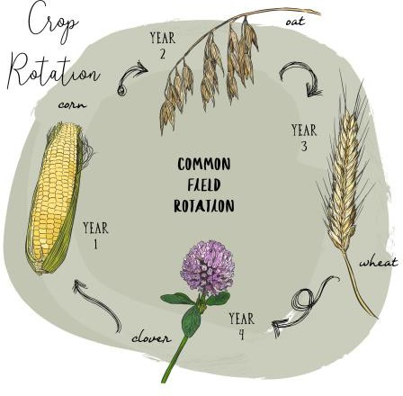Pests – pests like locusts or Japanese beetles enjoy certain types of crops. If you continue growing the same crops, these pests will stay
* Disease – diseases like black spot or blight will survive in the soil year after year if crops are not changed

# Benefits of Crop Rotation

If you use crop rotation, you will have less weeds, pests and diseases on your farmland.

Another benefit for using crop rotation is better soil.

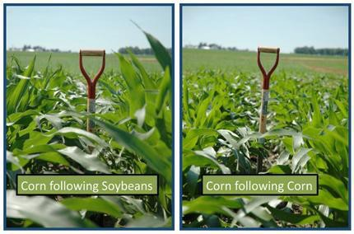When you grow a new crop, it has different nutrients in it. When it dies, those nutrients go into the soil, making the soil richer in different nutrients. If you only grow one type of crop for years and years, the soil will have less nutrients in it.

Common Crop Rotation – Corn and soybeans are commonly rotated year after year. Corn needs lots of nutrients, especially nitrogen. Adding nitrogen to the soil is expensive for farmers, so instead, they grow soybeans the year before growing corn. When soybeans decompose, they provide the soil with nitrogen, which then naturally fertilizes the soil for the corn the next year.