**Climate Vs Weather**

**Infobook**

**Quick description**

Weather refers to the short-term atmospheric conditions that we see at any one moment

Climate refers to the average conditions found in the atmosphere over a long period of time.

**Climate VS Weather**

Weather is the combined short-term conditions found in the lower atmosphere.

These conditions include precipitation, or rain and snow, as well as wind, atmospheric pressure, storminess, cloudiness, and various other atmospheric conditions.

What will the weather be like in exactly 37 days? Will it be rainy or sunny? Cold or warm? It is impossible to know. Weather patterns are erratic and very difficult to predict. Weather is an ever changing short-term, localized **phenomena**.

Climate, on the other hand, refers to long-term atmospheric conditions.

The climate of an area is determined by the average weather patterns taken over a long period of time.

It includes the extreme highs and lows, and the common weather that an area sees day in and day out. Understanding the climate of an area helps us know what type of weather we can expect. We may not know specifically what the weather will bring in 37 days, but understanding the climate allows us to make educated guesses. If we live in a rain forest, it is likely that the weather will bring rain in 37 days. If we live in a desert, there is a high probability that 37 days from today will bring heat and sun.

**Climate is a country’s normal weather over a long period of time.  By climate we mean a country’s rain and sunshine, winds, storms and everything else that makes up the weather.**

**Main Climates**

We can divide the world’s climates into three main groups:

* Arctic (or Frigid) zones, round the North and South Poles
* Tropical zones, round the Equator
* Temperate zones, in between the Tropical and Arctic zones

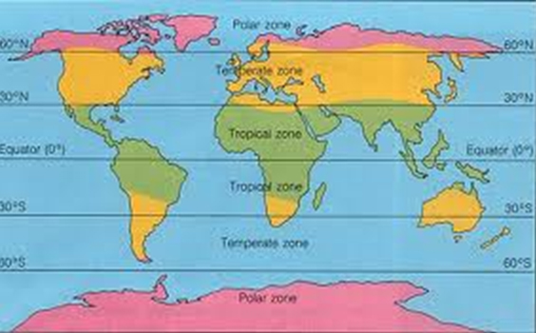

**Arctic climates**

Arctic climates can be subdivided into two, polar climates and sub-arctic

climates.

The Polar climate of the Arctic (round the North Pole) and the Antarctic (round the South Pole).  The climate round the North and South Poles does not support life.  In the Antarctic the temperature never goes above freezing.  For a short period in the Arctic temperatures may move above freezing and the ice can melt.

The Sub-Arctic zone covers places such as Greenland, Labrador, Alaska, the far north of Canada, the far north of Scandinavia and Siberia.  In winter in these areas temperatures remain below zero and the rivers and lakes remain frozen.  In summer there is a thaw, and the plants on the *tundra* can support animal life.





Tropical Climates

The areas between the Equator and the lines of latitude 30 degrees north and south have hot, tropical climates.  There are three main sub-divisions of tropical climates.

Equatorial climates are found along the equator.  These climates have rainfall all year. Temperatures are always high and the rain falls daily in heavy thunderstorms.

Tropical climates (in the true sense) are to the north and south of the equatorial climates.  Temperatures are always high and in summer they have heavy rain.  In winter the dry Trade Winds blow and there is less rain.

Hot desert climates are very dry and hot, with almost no rain at all.  Examples of desert climates are found in North Africa (the Sahara Desert), in Arabia, in southern California, and in parts of Australia.

**Temperate climates**

The temperate climates can be divided into warm temperate climates and cool temperate climates.

The warm temperate climates include the Mediterranean climate. Summers are hot and dry and winters are mild and wet.

Cool temperate climates are climates such as that found in the British Isles, northern Europe and New Zealand.  Summers are warm and winters can be cold, with snow and freezing temperatures for short periods.  Rain falls throughout the year, but there is more rainfall in winter than in summer.

**Climate Controls- What effects climate**

Latitude, Distribution of water, Circulation of air and water, Mountains Altitude Heating and Cooling of the Atmosphere and Seasons,

all can affect the climate of a region.

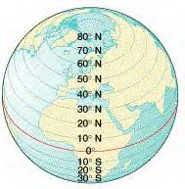**Latitude**

The first of these controls is latitude. Latitude is the measurement in degrees of the distance from the equator to any location on the Earth. The latitude of a location determines the amount of sunlight that a location will get. The higher your latitude, the less sunlight you will receive throughout the year, and the cooler will be your climate.

Locations near the equator receive vast amounts of sunlight throughout the year and as a result are warm year round. Locations near the poles get very little sunlight and as a result are cool year round.

**Distribution of water**

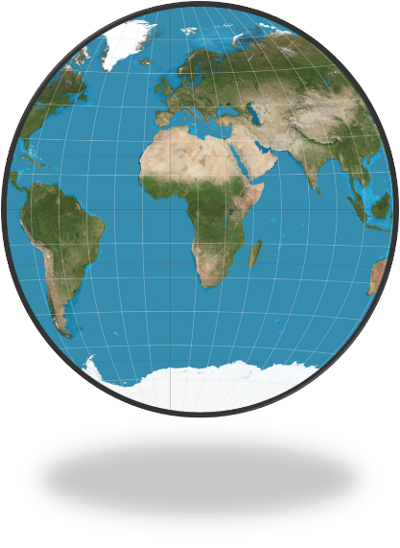The distribution of water and land across the surface of the Earth is another important control that regulates climate. Water responds to temperature change much more slowly than does land. It takes longer to heat water, and longer for it to cool down. As a result, locations near the oceans experience milder changes in climate.

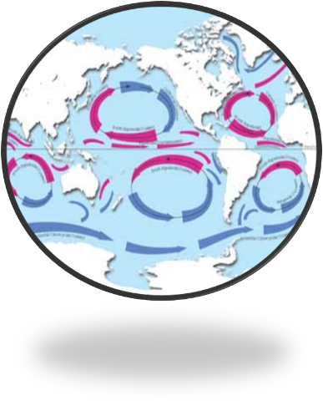

**Circulation of air and water**

Another important control is the circulation of water and air. Both the atmosphere, as well as the oceans are in constant motion. These motions carry heat around the world in regular patterns. Warm air and water are transported up towards the poles, while cool air and water are transported down towards the equator.

**Mountains**

Mountains can often act as barriers, diverting wind and moisture, affecting the climate in the areas around it. The side of a mountain facing the wind will have a climate very different from that of the other side of the mountain. Often mountains create a vast shadow where rain can seldom fall. With rainfall being blocked by vast mountain ranges, these areas become deserts.

**Altitude** (height above sea level) also affects climate.  The higher a country is, the colder it is.

Climate can be very varied even inside a small country.  In Great Britain, the north of the country is much more mountainous than the south, so the climate of northern Scotland is much wetter than the climate of southern England, although they are only 600 miles apart.

This division into climate zones looks very simple, but we know that there are many differences between climates even with one climate zone.

Climate does not just depend on how far from the Equator or the North Pole we are.  It also depends on how high a country is or how near the sea it is.

**Heating and Cooling of the Atmosphere**

How does heating and cooling affect the landscape around us? As the seasons change, what changes do you see outside? If you live in a temperate zone, the cooler weather probably brings changing leaf colors and hibernating animals. Later as the warm weather once again returns, so does life. New leaves, flowers, and baby animals welcome spring.

Other areas experience dry and wet seasons. The wet seasons bring life to the vast grasslands. Pools fill with water, frogs and fish come to life. Animals from hundreds of miles around migrate following the rain. Later as the rain slows down and the pools dry up, animals and plant life disappear.

Temperature has a dramatic and complex effect on the environments around us

**Seasons**

Seasons are as old as the earth. We tell time by them, plan our calendar around them and look forward to the changes they bring. But where do seasons come from? Does everyone have seasons? How do they vary in different parts of the world?

Seasons are created by two very important events – the rotation of the Earth that gives us day and night, and the rotation of the Earth around the sun that gives us our year. Because the sun never changes, only the movement of the Earth creates changes in light and darkness, and in temperature.

The orbit of the Earth around the sun is elliptical (a squashed circle), and the planet does not sit straight up and down. It sits at a tilt. As the Earth moves in its path around our star, there are times a certain part of the planet is closer to the sun. If the axis (the imaginary straight line around which the Earth rotates to make day and night) is pointing toward the sun, that hemisphere can expect summer. If the axis is pointed away from the sun on the Earth’s yearly trip, that half of the planet will see winter.

Seasons

Because of this, the Northern Hemisphere of the planet has summer while the Southern Hemisphere experiences winter. It seems as strange for kids in Australia to imagine a white Christmas as it is for kids in New York to think of splashing in the pool in December. That is how it works, though, when the two hemispheres of the Earth are opposite in seasons!

Because seasons are based on the rotation of the planet around the sun, the seasons change at the same time every year, even though the two halves of the planet experience opposite seasons!

Seasons change on or around the 21st of four months: June, September, December and March. In the Northern Hemisphere, December begins winter, March brings on spring, June means summer is beginning and September gives autumn weather. In the Southern hemisphere, the opposite is true. December starts summer, March is the beginning of fall, June starts the winter season and September brings spring.

Some regions do not experience seasons the same way as others, but all parts of the Earth have seasonal changes. For the Polar Regions (the areas at the top and bottom of the Earth) and the temperate zones (the area around the middle), seasons change the amount of daylight and darkness they experience more than the temperature.

At the poles, it stays cold, even in summer, but the daylight seems to never end. The poles will go months without darkness while they are pointed at the sun. During the winter, when they are far from the sun for months at a time, darkness rules, and no sunlight is seen.

In the temperate zones, it stays warm during the winter. But the days are long during the summer and shorter during the winter. That is important for plants and animals, which need the seasonal changes to grow and develop correctly, even though the temperature change is small.

Seasons are important all over the Earth, and each part of the planet experiences some type of change as their pole tips toward the sun for three months out of the year. Seasons make our lives more interesting and give us ways to mark the passing of time. They help nature stay in balance, too. It’s a good thing our planet's axis tips!

**What affects Temperature?**

**Heat and Weather**

The amount of energy absorbed by the Earth from the Sun, and the amount of energy radiated into space by the Earth is on average perfectly balanced on an annual or yearly basis. However, as previously discussed, some locations are warmer or cooler than others. This is the principal cause of weather.

As the gases in Earth’s atmosphere heat up, they begin to expand, or spread out. As this happens, air begins to rush outward towards places where there is less pressure. In other words, towards places where the air is cooler.

What do you suppose rushing air feels like? Have you ever experienced rushing air? If you guessed that this is what causes wind, then you are absolutely correct.

This wind affects storminess, precipitation, and many other aspects of the Earth’s weather. Thus, the unequal heating of the surface of the Earth is the principal cause of weather. There are a number of factors that cause this unequal heating of Earth’s atmosphere.

**Latitude Affects Temperature**

One of the primary factors affecting the unequal heating of the Earth’s atmosphere is latitude. Latitude is the measurement of the distance of a location on the Earth from the equator. The further away from the equator that a location resides, the less sunlight that this location receives.

It all has to do with the shape of the Earth. Because the Earth is round, only the front most portion receives direct sunlight. The more direct the light is, the more intense it is, while less direct light is less intense. The angle at which light strikes the surface of the Earth is known as the angle of incidence.

**Day Length Affects Temperature**

Another important factor that has a direct impact on the heating of the Earth is the length of a day. The longer that a day lasts, the more time that there is for Earth to absorb energy from the Sun. Thus, longer days typically result in warmer days, while shorter days result in cooler days.

On the equator, the length of days changes very little throughout the year. Daylight shines for almost exactly 12 hours, and darkness reigns for almost exactly 12 hours. The further away that one travels from the equator, however, the more variation in length of day that will be observed. In the summer days stretch out, becoming much longer than the nights, while the opposite is true in the winter, when night lasts longer than day.

**Atmospheric Obstructions Affect Temperature**

In earlier chapters we have discussed the many particulates that exist in our atmosphere. Tiny particles of dust, water vapor, pollen, animal hair, and microscopic life absorb, scatter, and alter the Sun’s energy before it can reach the Earth’s surface. Increasing the levels of these particulates blocks more of the Sun’s energy from reaching the surface, causing a decrease in temperature. One way that particulates are increased is via cloud cover. The clouds block the heat and light from the Sun, making for a cooler day.

**Land and Water Affect Temperature**

The atmosphere of the Earth is primarily heated by radiation coming off of the Earth. 50% of the Sun’s energy is absorbed by the Earth and then released back into the atmosphere. Thus, the temperature of the air in a given location can be greatly affected by the materials found on the surface.

Some materials absorb more energy, while other materials reflect more energy. Organic materials such as plants and animals tend to absorb more energy than do barren deserts. Thus, the air temperature in a forest is usually cooler than the temperature in a desert. Likewise, the blacktop, rooftops and buildings of a city act like a desert, raising the temperature of an area by as much as 10 degrees.

Water absorbs vast amounts of energy from the Sun. Likewise, bodies of water release energy very slowly. For this reason, areas near water are usually milder. Because of water’s ability to absorb heat, store it and release it later, the oceans of the Earth have an important role in helping to moderate the Earth’s temperature.

**Our Atmosphere Transfers Heat**

Like an unbalanced teeter-totter falling to one side or the other, the Earth is constantly trying to balance temperature differences. The cooler areas attract warm air, while the warmer areas push air outward in an attempt to cool itself down, until a perfect balance is reached everywhere. Due to the unequal heating of the Earth’s surface, this balance is, however, never reached.