NAME:

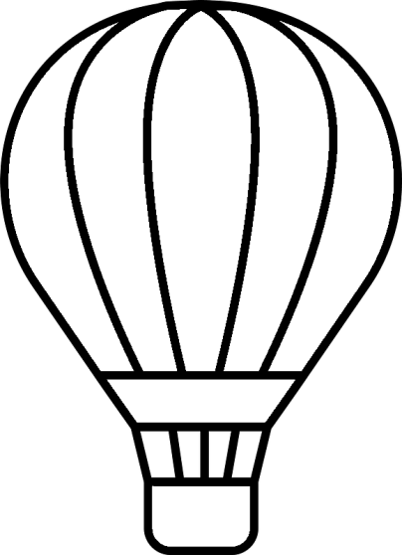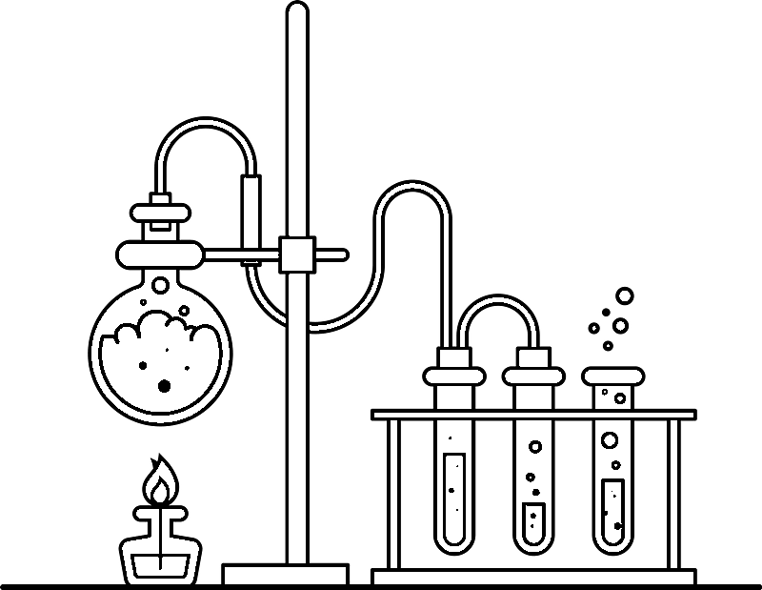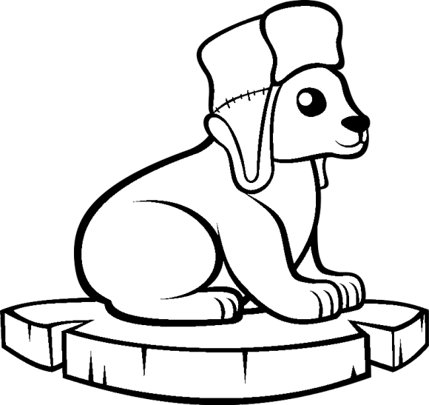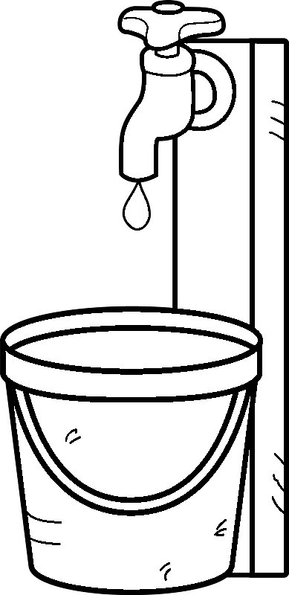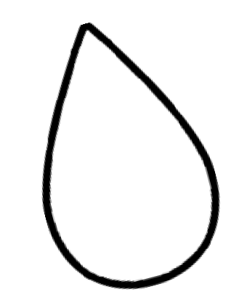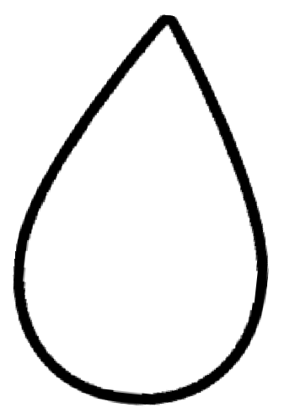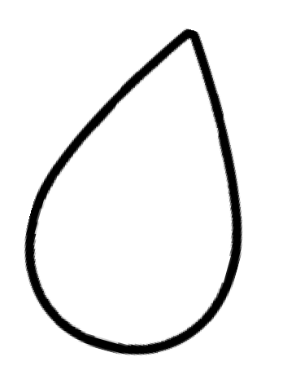

Name 6

Curriculum Connection M.1

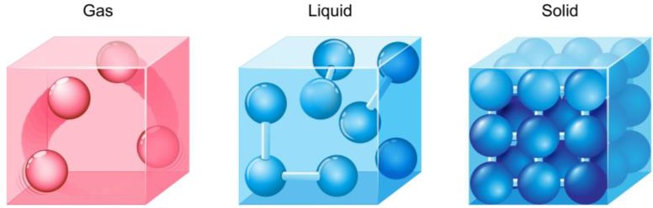

# What is Matter?

Everything is made of matter. Look around. The desks in your classroom are made of matter, the air we breathe and the water we drink are

all made of matter. Even our bodies are made of matter!

**Matter** is everything that has mass and occupies volume. Air is matter because air has weight and it takes up space. We know this because a balloon that is full of air weighs more than an empty balloon. Air also takes up space because when we blow up a balloon, the air pushes on the balloon, expanding it.

A desk is also matter. It weighs something, meaning it has mass and it takes up space. When something takes up space we say it occupies **volume**.

# Particles - Atoms

All matter is made up of tiny particles called atoms. When you look at matter, you can’t see the tiny atoms. Even with the best light microscope, single atoms cannot be seen. But, atoms are there. You are made of 7 billion billion billion atoms, or 7,000,000,000,000,000,000,000,000,000.

# Phases of Matter

All matter can be grouped into three phases – solid, liquid, or gas. An example of matter that goes through the three phases of matter is water. Water can be ice as a solid, regular water as a liquid, and steam as a gas.

The atoms in a solid are very close together, while they get further apart in a liquid, and very far apart in a gas.

Name 9

Curriculum Connection M.1

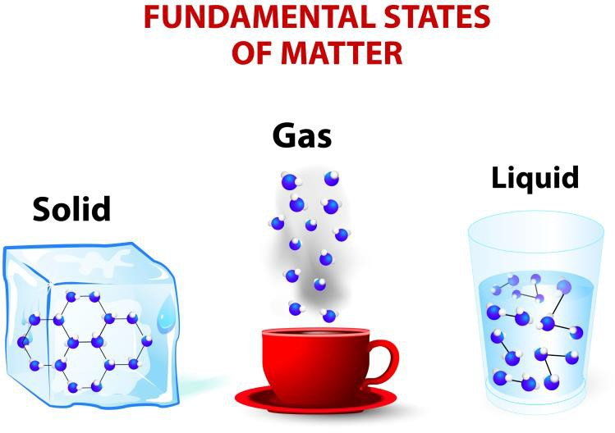

**The Particle Theory**

Matter can be classified according to its physical characteristics. The particle theory of

matter helps to explain the physical characteristics of matter.

1. Everything is made of particles
2. There are spaces between the particles
3. Particles are attracted to each other
4. Temperature affects the speed at which particles move
5. Particles are always moving because they have kinetic energy
6. There are different kinds of particles, but all particles of one substance are identical

Solids

In solid form particles are close together. The particles are very strongly attracted to each other. They are locked in a pattern and vibrate in place. Solids have a fixed shape and volume. The spaces between the particles are small.

Liquids

In liquid form, particles are slightly farther apart. Particles are less attracted to each other and are able to slide past each other. The spaces between the particles are larger than in a solid.

Gas

In gas form, particles are far apart and can move in any direction because the attraction forces between them are weak. Gases have no fixed shape and no fixed volume. They expand to fill their container.

Name 11

Curriculum Connection M.1



**Physical Properties of Matter**

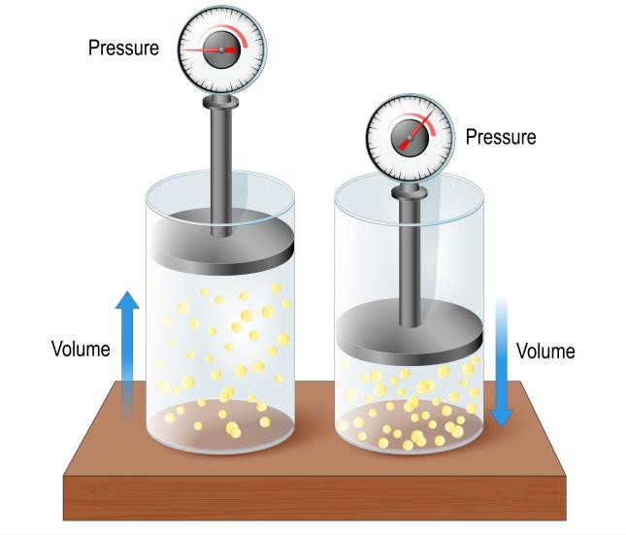

Matter is everything around us that has mass and takes up space. There are five physical properties of matter: state, mass, volume, density, and compressibility.

1. **State of Matter**

The "state" refers to whether matter is a solid, liquid, or gas. Solids have a fixed shape and volume. Liquids can change shape but have a fixed volume. Gases can change both shape and volume.

1. **Mass**

Mass is the amount of matter in an object. It is usually measured in grams (g) or kilograms (kg). For example, an apple might have a mass of 100 grams.

1. **Volume**

Volume tells us how much space matter takes up. It is measured in cubic units (like cubic centimeters) or in milliliters (ml) and liters (l) for liquids. For instance, a bottle of juice might have a volume of 500 milliliters and a Rubik’s Cube could be 27 cm3.

1. **Density**

Density is how tightly packed the matter in an object is. It is found by dividing mass by volume. An object with high density has a lot of matter in a small space. For example, a bowling ball is dense because it has a lot of matter

packed into a small space.

1. **Compressibility**

Compressibility is a measure of how much the volume of matter decreases under pressure. Gases are highly compressible, while solids and liquids are not. For instance, you can compress the air in a bicycle pump, but you can't compress the bicycle itself.

Name 13

Curriculum Connection M.1, M.3

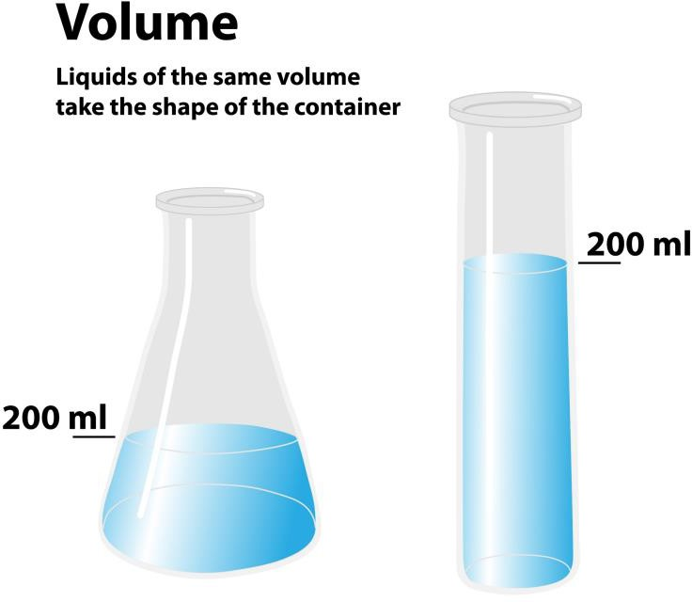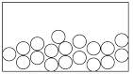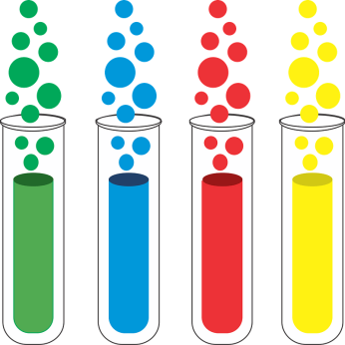

# Liquids

A **liquid** is a form of matter that can be poured. When you pour a liquid, it will always take the shape of its container. We pour liquids into cups when we need a drink. The liquid will always take the shape of the cup you are using. The most common form of liquid is water.

Liquids all have weight and take

up space. Liquids have a definite volume. This means if you put 1 cup of water into a bowl or into a tall glass, it takes up the same amount of space. The volume of a liquid refers to how much space the liquid takes up.

Liquids can change their state of matter. Liquids can be made into solids when you cool them to their freezing points. Liquids can be turned into gases when you heat them to their boiling point. The freezing and boiling point for each liquid is different.

# Properties of Liquids

* Do not have a definite shape
* Take the shape of their container
* Fill the bottom of a container or spread when they are not contained
* Maintain the same volume in different containers
* Are difficult to compress or squeeze because the particles are close together

Name 17

Curriculum Connection M.1

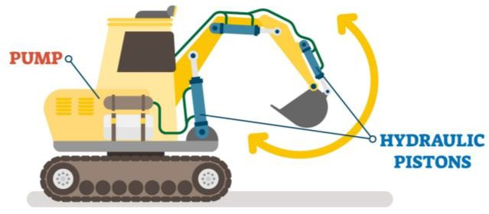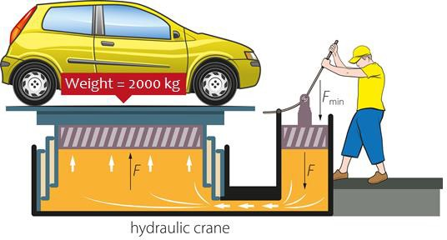

# Properties of Liquids

* Not rigid
* No fixed shape
* Fixed volume
* Cannot be compressed (squashed)

# Applications of Liquids

Liquids are used in a variety of ways in our lives because of their properties.

1. We use liquids to lubricate engines so that friction doesn’t cause the engine to seize. Oil is the liquid that is poured into engines. The liquid oil can change its shape to fit into all areas of the engine, ensuring parts do not rub together.
2. Liquids are used in hydraulic systems to generate strong forces. Liquids cannot be compressed, so when a piston pushes on a liquid, the liquid pushes a piston on the other side of the hydraulic system with the same force. This transmits our force from one place to another.

When we use a smaller piston to move a larger piston, our force is multiplied, allowing us to generate more force.

Hydraulic brakes use our force on the brake pedal to stop the wheels on our tires.

1. Liquids have a fixed volume, meaning they will take up the same amount of space regardless of how you position the liquid. When you fill your bottle with water, you can move the bottle around and the liquid will not expand or condense. It will continue to take up the exact same amount of space.

Name 19

Curriculum Connection M.1

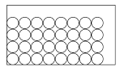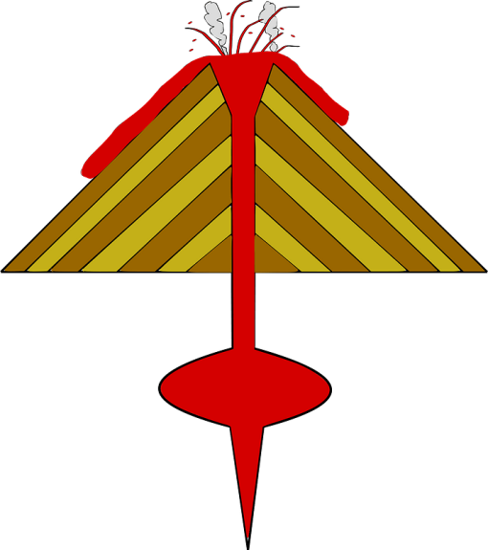

# All About Solids

Solids can have a lot of different characteristics. Many solids are hard like your desk, the walls and floors. Solids can also be soft, like a cotton ball. Some solids like play dough and clay can be molded so you can change their shape.

They are all still solids. When you break a solid, it stays a solid in more than one piece. When you break a cookie, it will be solid pieces and crumbs, but it will not become a liquid.

The particles do not move or spread out to fit the container

Therefore, solids:

* Can’t be poured
* Holds their shape unless an outside force acts upon it (example – cuts it)
* Has a definite shape (do not take the shape of their container)
* Is difficult to squeeze as the particles are already packed tightly
* Is dense because there are many particles packed closely together
* Can be described in many ways, including hard, soft, rough, smooth, flat, round

# Solids Can Melt

When a solid is heated to its melting point, it will turn into a liquid. Some solids, like ice, will change into a liquid at room temperature. Other solids, like rocks,

will need to be heated at very high temperatures to melt.

Rocks will melt under the ground in magma. Magma

is melted rock. When magma comes up to the surface through a volcano, it is called lava.

Name 21

Curriculum Connection M.1

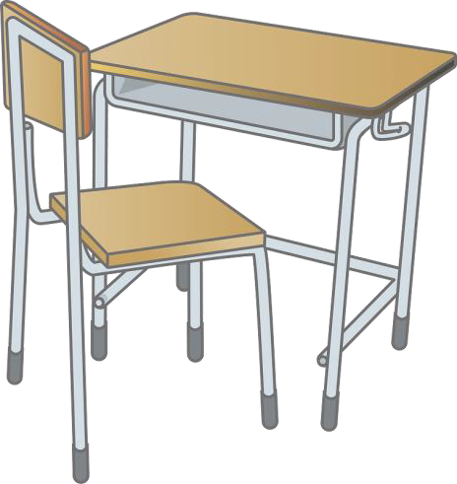

# Properties of Solids

Solids have the following general properties:

* Rigid
* Fixed shape
* Fixed volume
* Cannot be compressed (squashed)

# Applications of Solids

Solids are used to create the structures we have in our lives. We use solids because they are rigid, have a fixed shape and volume, and they cannot be squashed.

Solids are **rigid,** meaning they have a certain structure that will not change shape. Solids are great to build structures that need to be strong. A chair is made of rigid solids, like wood, steel, and hard plastic.

Having a **fixed shape** means the solid will not change its shape when you move it or apply pressure to it. A **fixed volume** means the solid takes up the same amount of space. A desk has a fixed shape that does not change its volume. This is helpful so you can work on the desk and know it won’t change its shape. Your teacher appreciates that it has a fixed volume, meaning it won’t expand or grow!

Solids cannot be compressed, meaning you can’t squeeze them. If you’re thinking a sponge is a solid that you can squeeze, your misunderstanding that the solid has air inside that you are squeezing.

Solids need to be strong and stable, which is why it is good they can’t be compressed. If the road vehicles drive on

compressed under heavy loads, the road would eventually be very thin. A thin road would crumble under the changing weather and heavy loads.

Name 25

Curriculum Connection M.4

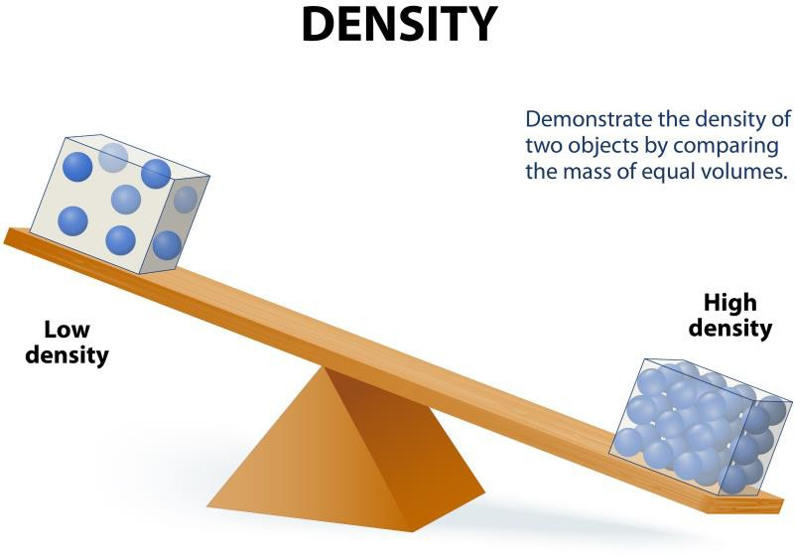

**Sink or Float?**

When we mix a solid with a liquid, sometimes

the solid dissolves so we can’t see it. Other times, the solid sinks or floats. For example, sand will sink in water. This is good because if sand floated, our beaches would be a mess!

**Density of Solids**

Solids will sink or float because of their density. Remember that solids are made of particles. **Density** is how tightly packed the particles are. A highly dense solid has very tightly packed particles, like a rock or nickel. They are heavy compared to their size.

A solid with a low density has loosely packed particles. This makes the solid light compared to its size. Examples of solids with a low density are plastic water bottles, paper, leaves, feathers, and sponges.

**Density of Water**

Water is made of particles as well. So, water has a density too. Water’s density isn’t high or low, it’s somewhere in between.

**Why Do Solids Sink Or Float?**

If a solid has a higher density than water, it will sink. It weighs too much compared to its size, so it cuts right through the water to the bottom.

If a solid has a lower density than water, it will float. When something floats, we say it is **buoyant** (BOY + UNT). A piece of Lego is buoyant. A brick is not buoyant.

Name 27

Curriculum Connection M.4

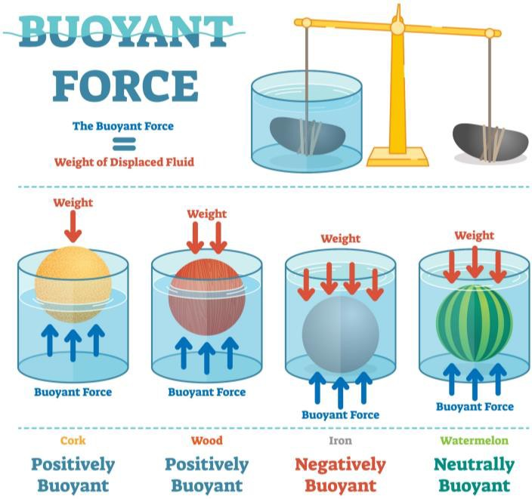

**What is Buoyancy?**

**Buoyancy** is an upward force created by a fluid that opposes the weight of an object. Buoyancy is why an object sinks or floats when put into a fluid, like water. All objects in water have some buoyant force pushing up against the gravity that is pulling that object down. If the buoyant force is not strong enough to push the object out of the water, it will sink.

**Types of Buoyant Forces**

Positively Buoyant

An object, like cork, is positively buoyant if its density is less than the fluid it is in. The result will be that the object floats in the fluid. In the diagram, cork is more positively buoyant than wood, but both float in the water, meaning they rest at the surface because their density is less than the water. They are both said to be positively buoyant.

Negatively Buoyant

An object is negatively buoyant if it sinks in water. This means if the object has a higher density than the fluid, it will be negatively buoyant. Negatively buoyant objects vary, meaning some negatively buoyant objects will take time to sink, while other negatively buoyant objects will sink right away, like a large rock. This is because the objects have different densities.

Neutrally Buoyant

A neutrally buoyant object does not sink or float. Instead, it remains balanced at the same level in a fluid. Scuba divers aim to be neutrally buoyant so they cannot feel the force of gravity or buoyancy while they explore underwater. They do this by wearing scuba gear that balances these forces.

Name 30

Curriculum Connection M.4

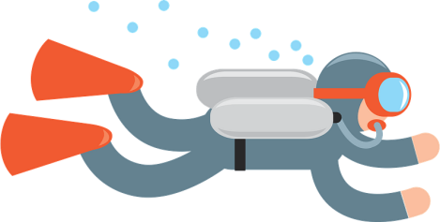

**Scuba Diving Safety**

Scuba diving is a thrilling activity that allows us to explore the magical world under the sea. However, to enjoy these underwater adventures safely, it's essential to understand the changes in pressure that occur during a dive and how to manage them effectively.

**Heading Underwater: Descending Slowly**

Divers need to descend slowly when they start their dive. One reason is to allow their bodies to adjust to the increasing pressure. But, more importantly, it helps

protect their ears. Inside our ears are tiny air-filled spaces that need to have the same pressure as the water outside to feel comfortable.

This is why divers often "pop" their ears while going down, which is a way of letting

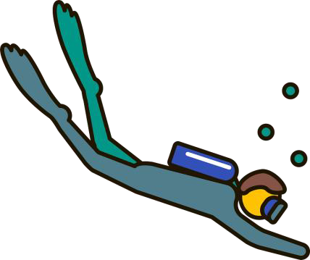more air in to balance the pressure. By descending slowly,

divers give their ears a chance to adjust gradually.

**The Dangers of Rising Quickly: Decompression Sickness**

When diving, the increased pressure causes the body to absorb more nitrogen gas from the air in the scuba tanks. Normally, this

nitrogen is not a problem as it gets naturally breathed out by our lungs.

However, if a diver comes up too quickly, the pressure around them decreases faster than the body can remove the extra nitrogen gas. This can cause the nitrogen to form bubbles inside the diver's body, leading to a condition called decompression sickness, also known as "the bends". This can result in joint pain, dizziness, and even death.

To avoid decompression sickness, divers come up slowly and perform what's known as "decompression stops". These stops are like short breaks at certain depths where the diver waits for a while. This gives their body time to safely release the extra nitrogen gas.

Name 40

Curriculum Connection M.1

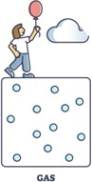

# All About Gases

Matter can take the form of a gas. A gas is an invisible form of matter. The air in the room you are in is a gas. We cannot see the air, but we can feel it when we swing our hand back and forth.

The spaces between gas particles are very big, which gives the particles room to move around quickly. This is because the particles have very little attraction between them. The particles are free to move in all directions.

As a result, gases:

 do not have a definite shape

 take the volume and shape of their container or spread when not contained

 are easily compressed because there are less particles in the space they are in

 are often low density because there are not many particles in a large space

# Transforming a Gas

A gas will commonly transform into a liquid through the process of condensation. Condensation occurs naturally in our environment when water vapour fogs up our glasses or when vapour forms water droplets on the glass of a cold drink.

A gas can also transform directly into a solid through the process of deposition. An example of this is frost. Frost happens when water vapour from humid air turns directly to ice.

# Examples of Gases

Oxygen is one of the many gases in the air we breathe. Carbon dioxide is a gas we

breathe out. Helium is a gas we use to fill balloons so they can float.

Name 44

Curriculum Connection M.1

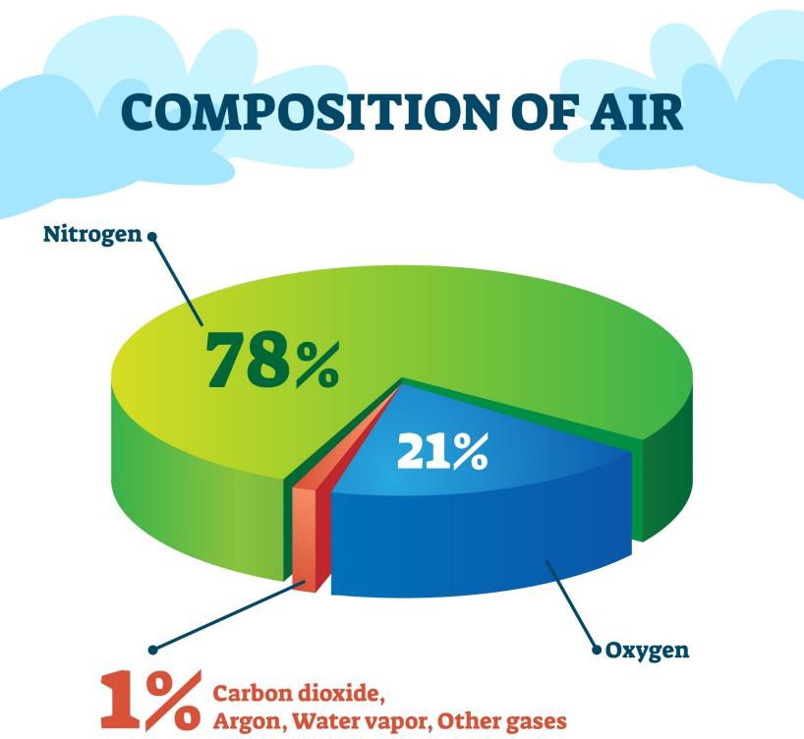

# All About Air

Everything around you is matter. The air you breathe is matter. The juice you drink is matter. The chair and desk in the classroom are both matter. They are all different kinds of matter. Matter can be liquid, solid or gas.

Air is matter in the form of a gas. We cannot see air, but it is all around us. Air covers the earth in a layer that is several kilometers deep. This layer is called the earth’s **atmosphere**. If you go to outer space, you leave the atmosphere and won’t have air to breathe!

Air is made of several different kinds of gases. Air is made of:

* Nitrogen ➔ 78 percent
* Oxygen ➔ 21 percent
* Carbon Dioxide
* Water Vapour
* Argon
* Rare gases

# Properties of Air

* We cannot feel air unless it is moving, like on a windy day
* We cannot see clean air
* Air has no colour, unless it is dirty
* We cannot smell air unless it

is polluted. Clean air has no smell

* Air is a gas and a fluid. We know this because planes can fly through the air!

Name 46

Curriculum Connection M.1

# Properties of Liquids

* Not rigid
* No fixed shape
* No fixed volume
* Can be compressed (squashed)

Compressing

# Compressed Gas

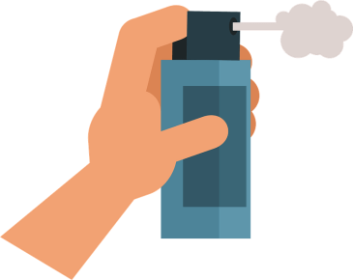

Gases can be compressed, which allows humans to use them to their advantage. **Compressed gas** is a gas that has had its pressure increased by the reduction of its volume. Compressed gas is stored in strong containers that can support the pressure created by the shrinking of the volume of the gas.

The diagram shows how gas can be compressed so that the particles of the gas are forced to occupy a smaller volume due to the compressive forces. Gas can be compressed because its particles are spread out. When compressed gas is stored, it will create a force when it is released as the particles

will move quickly to expand all over their new container.

# Applications of Gases

* Carbon Dioxide in Soda – Carbon dioxide is compressed

inside soda cans to give the delicious acidic flavour and fizz. It is stored inside a can and not a juice box because the can is able to hold the compressed gas.

When you open the can, the carbon dioxide gas rushes out.

* Hairspray – Gas is compressed in hairspray bottles. It is mixed with the hairspray product. When you push the button, the gas rushes out along with the hairspray. This is why you need to shake the bottle before pressing the button.
* Air Compressor – Gas is stored in a tank so that it can create a force used in nail guns, paint sprayers, and many other tools.

Name 48

Curriculum Connection M.2, M.3, M.4

**Understanding Mass and Volume**

Let's start with mass and volume. The mass of an object tells us how much matter it contains, usually measured in grams (g) or kilograms (kg). The volume of an object tells us how much space it takes up, typically measured in cubic centimeters (cm³), milliliters (ml), or liters (l).

Imagine you have a large pillow and a small iron weight. Even though the pillow is bigger (has more volume), it has less matter (mass) inside than the iron weight.

**The Density Equation**

Next, we have density. Density is determined by the equation:

Density = 𝑚𝑎𝑠𝑠

𝑣𝑜𝑙𝑢𝑚𝑒

or p = 𝑚 where p equals density, m equals mass, and v equals volume.

𝑣

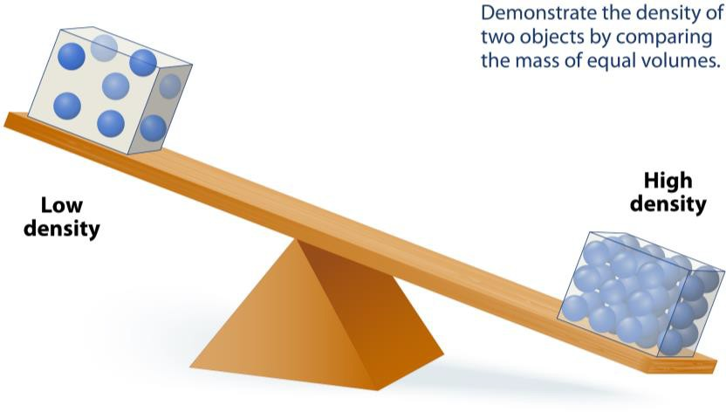

**High and Low Density Examples**

To better understand, let's consider some examples. A cork and a rock may have the same volume, but the rock has more mass. Why? Because the matter in a rock is packed tightly

together, so it has a higher density. The cork, however, has less mass because its matter is spread out more - making it less dense.

* High-Density Solid: Lead is an example of a high-density solid. It has a density of 11.34 g/cm³, which means there's a lot of mass packed into a small volume.
* Low-Density Solid: Balsa wood, used for light models, is a low-density solid, with a

density of about 0.16 g/cm³.

|  |  |  |  |
| --- | --- | --- | --- |
| **High Density Objects** | Steel | Brick | Hard Rubber |
| **Low Density Objects** | Sponge | Basketball | Cork |

Name 61

Curriculum Connection M.5

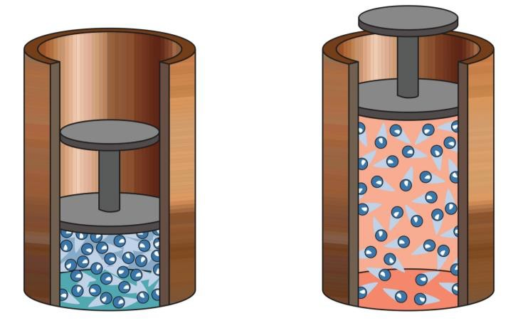

**What is Compressibility?**

Compressibility is all about how much a substance can be squished or compressed. The more compressible a substance, the more it can be squished into a smaller space.

**The Particle Theory**

The particle theory tells us that everything is made up of tiny particles that are:

* Always moving
* Attracted to each other
* Have spaces between them

**Compressibility of Water**

Water is seen as incompressible. This means when we apply pressure, the particles of

water don't really get any closer together. Why?

* Water particles are already very close together
* The attraction between water particles is strong

So, when you try to squeeze a filled water bottle, the water itself doesn't get compressed. The shape of the bottle might change, but the volume of water stays the same.

**Compressibility of Air**

Unlike water, air is highly compressible. When we apply pressure to air:

* The particles, which already have a lot of space between them, are forced closer together
* Once the pressure is released, the particles move apart again

This is why your lungs can take in a large amount of air and compress it. When you let out

your breath, the air returns to its normal volume.

Name 67

Curriculum Connection M.5

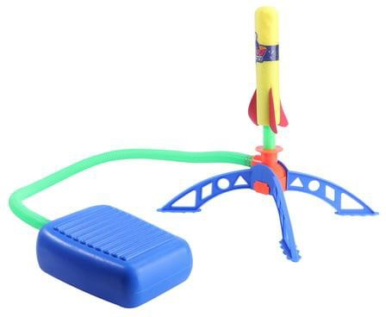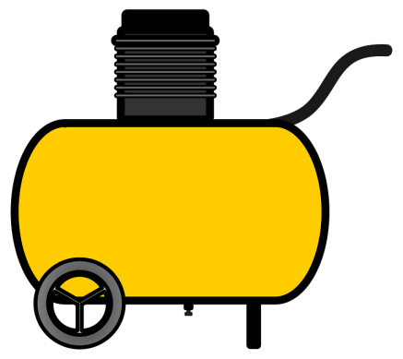

**What is Compressibility?**

Did you know that many of the machines and technologies we use every day rely on compressing air? Compressing air means pushing the air particles closer together. Let's explore three examples: air compressors, stomp rockets,

and pneumatic (air-powered) tools.

**Air Compressors**

An air compressor is a machine that takes in air, compresses it by pushing the particles close together, and then stores it.

When the compressed air is released into the air outside, it

moves quickly as the particles spread out to fill the volume of space outside. The movement of air makes energy that can be used to power different tools and machines.

**Stomp Rockets**

Stomp rockets are a fun toy that also uses air compression. They have a launch pad connected to an air bladder. When you

stomp on the bladder, it forces the air particles inside to

squish together. This increases the pressure. When the air

is released, it rushes up the tube and pushes the rocket into the air.

**Pneumatic Tools**

Pneumatic tools, like a jackhammer or a paint sprayer, use compressed air to work. The tool is connected to an air compressor. When you trigger the tool, the compressed air rushes out. The moving air particles create a force that powers the tool.

For example, in a paint sprayer, the compressed air pushes the paint out of the nozzle. These tools make our work much easier.

Name 69

Curriculum Connection M.5

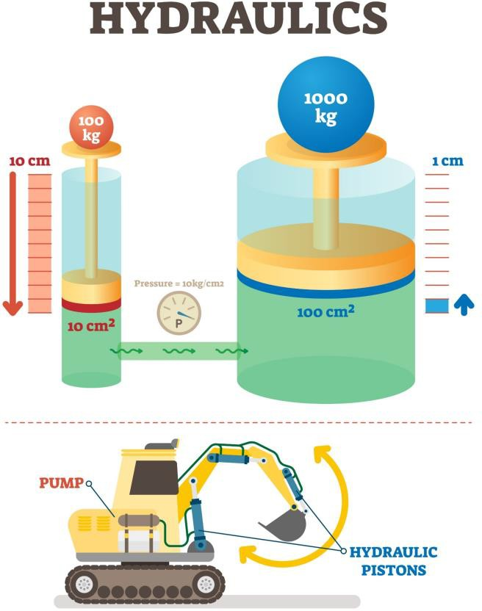

**Power of Water: Hydraulic Systems**

Water is an amazing substance. Not only do we need it to live, but we also use it in some interesting ways to help us do hard work. This is possible because water is almost impossible to compress.

**The Power of Water in Hydraulics**

Hydraulics is a branch of science that uses the power of liquids like water to make heavy work easier. In a hydraulic system, water is placed in a closed-off area. When we apply pressure to the water at one point, that pressure is transmitted evenly throughout the water and can be used to push something else.

**Example of a Hydraulic System**

Imagine you have two pistons, like big plungers,

connected by a tube filled with water. The pistons are different sizes - one is small, and the other is big.

If you push down on the small piston, it puts pressure on the water. Because water doesn't like to be compressed, the water pushes back and transmits that pressure along the tube to the big piston. The water's pressure then pushes up on the big piston.

Even though the big piston is larger, the pressure from the water can lift it. This is because the water transmits all the force you used on the small piston to the larger one. It's like having super strength!

This hydraulic system lets us lift heavy things with less effort. It's used in lots of machines like car brakes, construction equipment, and even amusement park rides.

Name 77

Curriculum Connection M.4

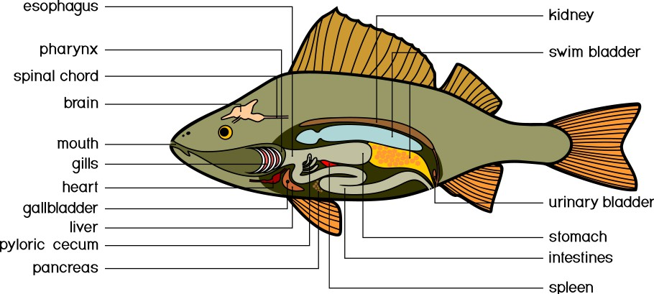

# The Swim Bladder - A Fish's Buoyancy Tool

The swim bladder works like a little inflatable balloon within a fish. The bladder can be filled with gas or deflated as needed.

# Swim Bladder in Action

* Going Deeper: If a fish wants to go deeper into the water, it lets some gas out of its swim bladder. This increases the fish's density, making it heavier than the surrounding water, which causes it to sink.
* Rising Up: To ascend to the surface, the fish fills its swim bladder with more gas. This decreases its density, making it lighter than the water around it, and it floats up.
* Staying Level: If the fish wishes to stay at the same depth, it can adjust the amount of gas in its

swim bladder to match the density of the water. This way, the fish can maintain a steady position without sinking or floating.

This is the key concept of buoyancy: objects that are

denser than the water will sink, and objects that are less dense will float. By

adjusting its density, a fish has the ability to control its position in the water.

# Fish Swim Bladders and Submarines - A Similar Technique

Just like fish, submarines also use the principle of buoyancy to move up and down in the water. Submarines have special tanks that can be filled with water or air.

* Diving: When a submarine needs to dive, it fills its tanks with water. This makes the submarine denser than the water around it, so it sinks.
* Surfacing: To rise to the surface, the submarine pumps the water out of the tanks and fills them with air. This makes the submarine less dense, and it floats to the surface.