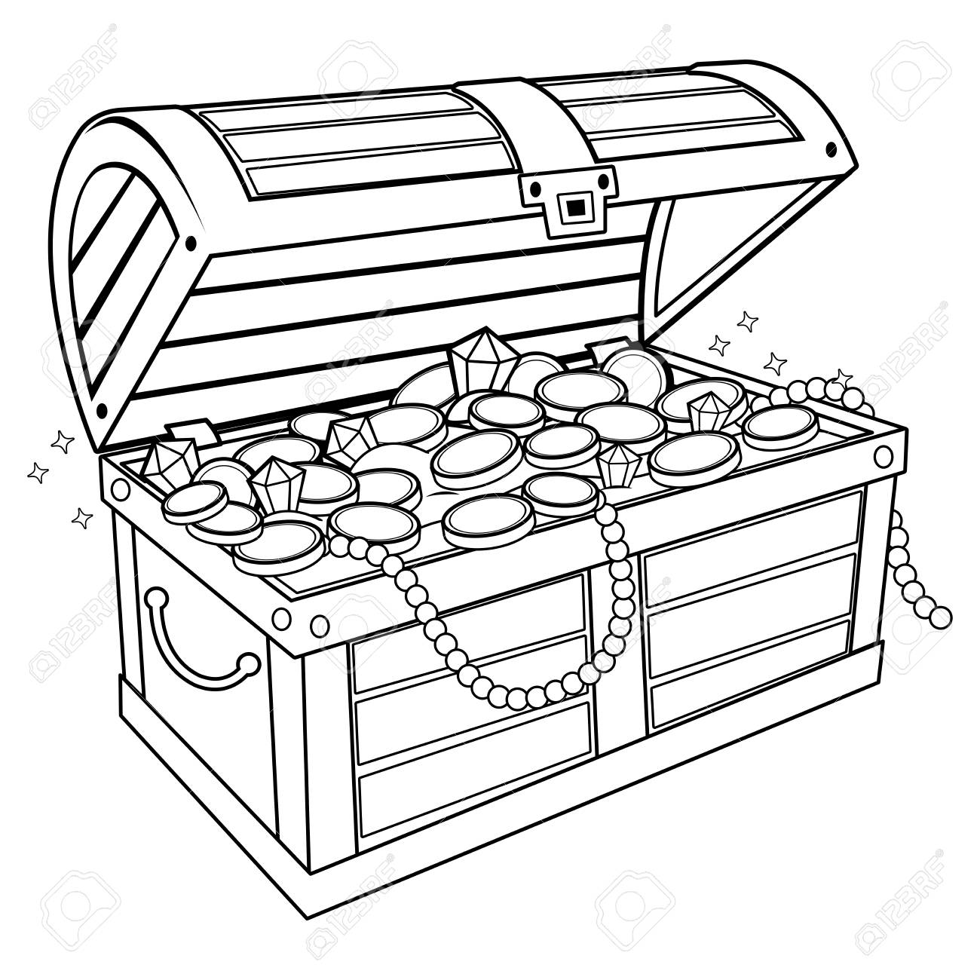
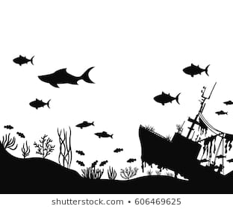
Sunken Treasure

The Goal of Sunken Treasure is to dive down to retrieve the treasure at the bottom of the ocean. You need to descend all the way down to zero to get to the treasure. At any point you may pause to conserve you air and then start again to get to the treasure. Watch out that you do not run out of air or that Pirates don’t seal your boat.

What you need:

2 or more players
2 dice (10 sided or 6 sided)
Each player needs a pencil.

How to play:
The first player rolls the dice and you add the two number on the dice together and subtract it from the total at the top of the column. Doubles and snake eyes do not count on the first roll. The dice go around the group clockwise, rolling each time, adding the two numbers together and subtracting it from the total. When you get to zero you get to take the treasure to the top and move onto your next dive.
Conserving air: Any player can pause their dive to conserve their air by putting down their pencil. A player that is conserving their air will not be affected by doubles or snake eyes, but they also will not get to subtract anything from their total. A player can pause for a maximum of two turns.
Doubles: If doubles are rolled any player that is not paused to conserve air will run out of air and be forced to go to the top and dive down again in the next column, they will not get any points for that dive.
Pirate eyes: If a player is not paused for a Pirate eyes (two ones for six-sided dice or double zero for 10-sided dice). They will lose all their points and must go to the next dive column.
The goal is to have the most treasure at the end of the 5 dives. Once a player is done their 5 dives the game is over and you total up your points.

