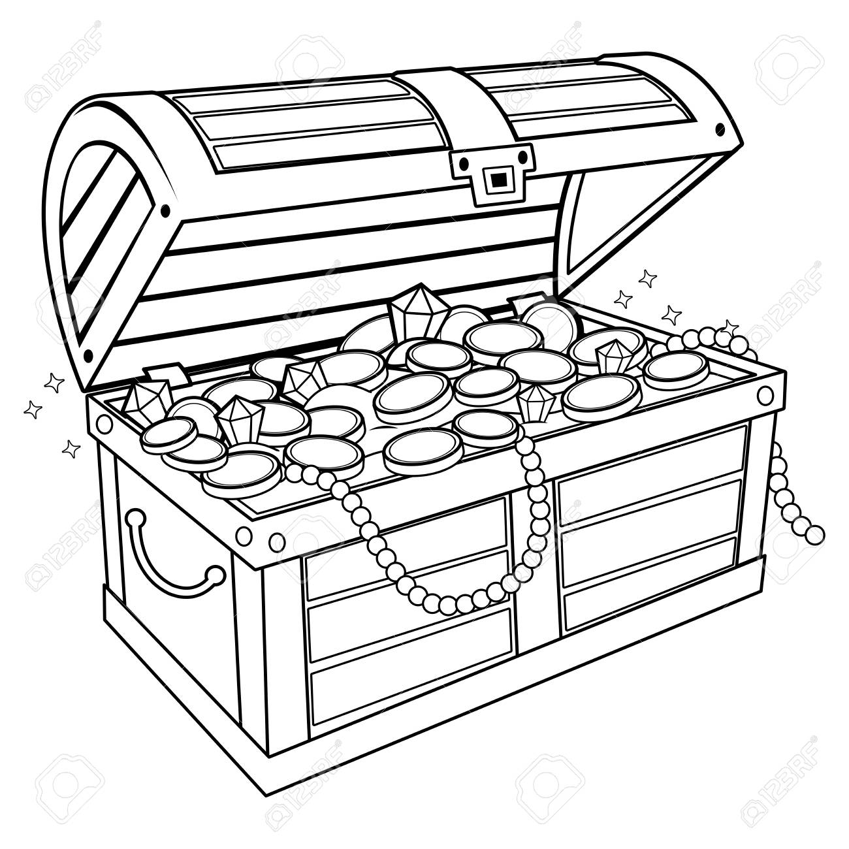
Sunken Treasure
Dive 1 | Dive 2 | Dive 3 | Dive 4 | Dive 5
100  -_________ | 150  -_________ | 200  -_________ | 250  -_________ | 300  -_________
100 | 150 | 200 | 250 | 300

Grand Total: _______________

Dive 1 | Dive 2 | Dive 3 | Dive 4 | Dive 5
100  -_________ | 150  -_________ | 200  -_________ | 250  -_________ | 300  -_________
100 | 150 | 200 | 250 | 300
Sunken Treasure

Grand Total: _______________

