Teaching Bible is like an Amusement Park
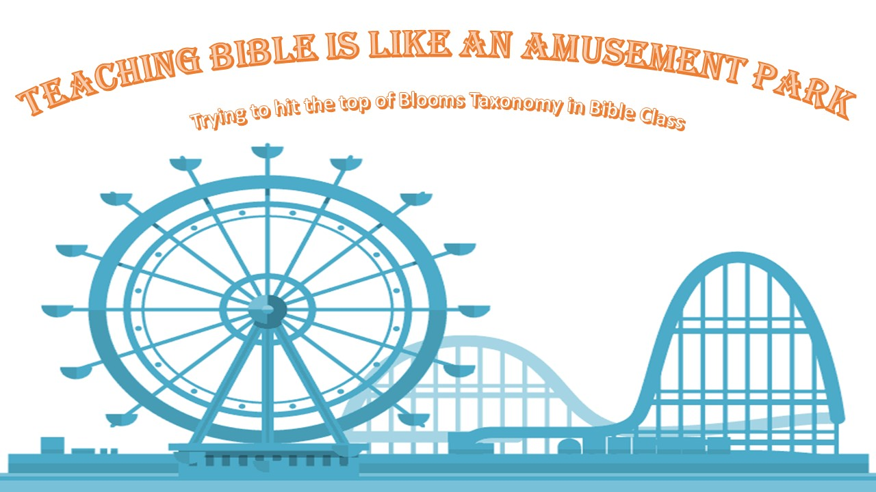
Trying to hit the top of Blooms Taxonomy in Bible Class

2019 PCCE Convention.
Presented by Alan Riewe
Alan.riewe@lethsd.ab.ca
Are there Height Restrictions in Bible class? What is preventing learning and what are the dire results?
At the symposium there were a number of glass shattering moments. These are things I had never thought of that may be causing students to be left out of learning in my Bible class.

Level of the text

- I was handing my students a book that’s reading level was 3-4 grades above their reading level.
  - This is way out of their zone of proximal development and could be incredibly discouraging.

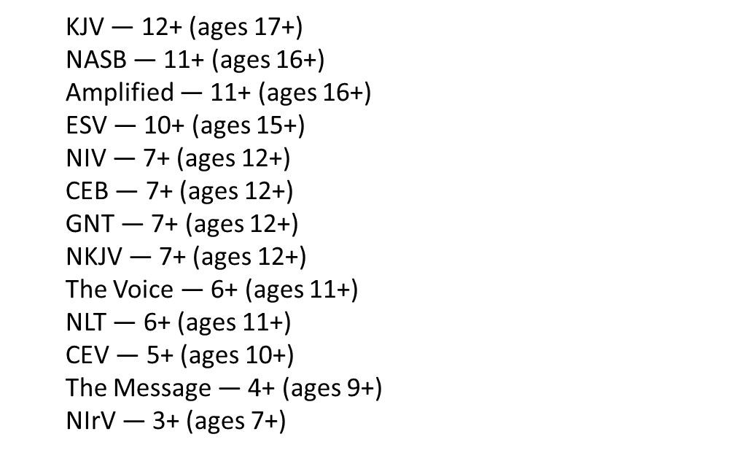
- Further to the point. Many of the translations that have a higher reading lever are a word for word translation. (or at least the best they can) This can lead to confusion as our students are not people growing up in the middle east 2000 years ago. So of their thoughts and saying would be lost on adults let along children.
  - In the lower levels it is more of a thought for thought translation.

Decoding the text
- I had never thought about how much decoding is required to read the Bible. We have students that are learning to read and we hand them a book unlike other books.
  - It has numbers and letters sprinkled throughout it is what can seem like random spots.
  - It has a whole bunch of extra information all over the page.
  - It is split into columns. (an extra skill to read)

Our foolish way of reading the Bible.
How many people would read a novel one page at a time? What a movie in 10-minute segments? Yet most reading plans are a page or two at a time.
Are there height restrictions in Bible class?

Are there height restrictions in Bible class?

Solutions

- Keeping a few different translations in class and guiding those copies to the people who need them.
- Using audio versions of the Bible
- Holy Bible app has audio Bibles of most translations
- Bible gateway.com also has many audio versions.
- If you are working on smaller sections printing it out with titles chapters and verse numbers removed.
- Consider printing on color paper as it makes it easier to read. Blue is the easiest.
- Dedicate time to read large sections to get kids captivated in the story.
  - I read my class last year Jonah all the way through. Even though almost all could have told the story of Jonah they were captivated by the reading.

FOMO in Bible instruction. (Fear of missing out)

A concern with Bible instruction in a Christian school setting is about missing parts and only covering favorite sections. There is so much to cover.
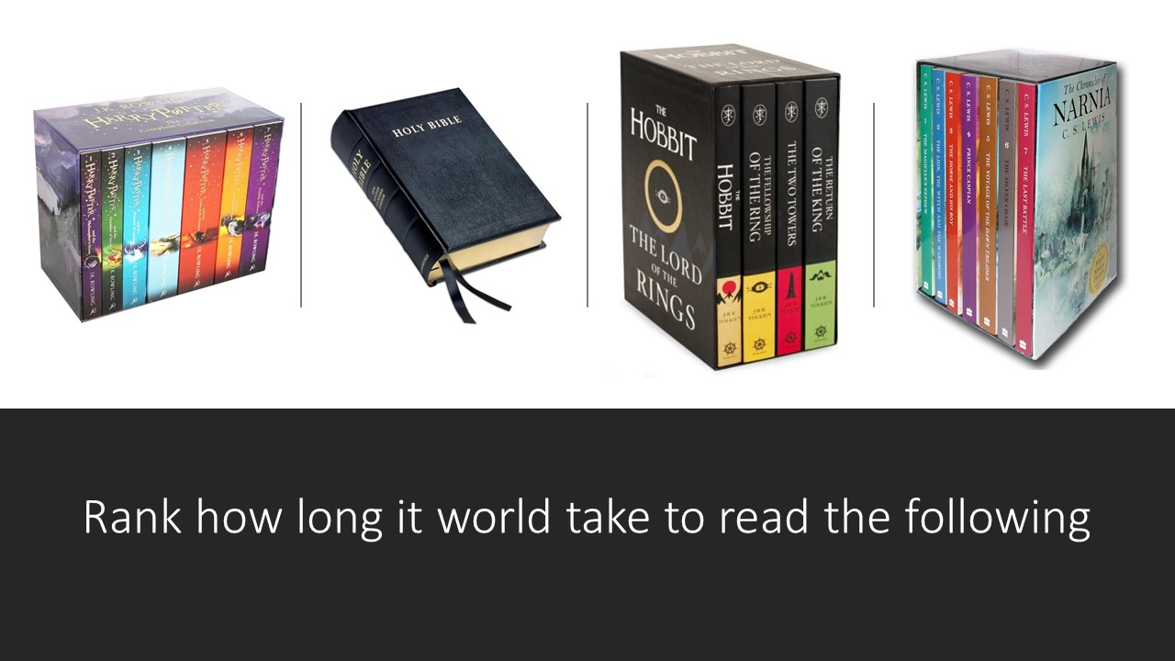
Would we think it unbelievable for a student to read any of these in a year let on during their school career.
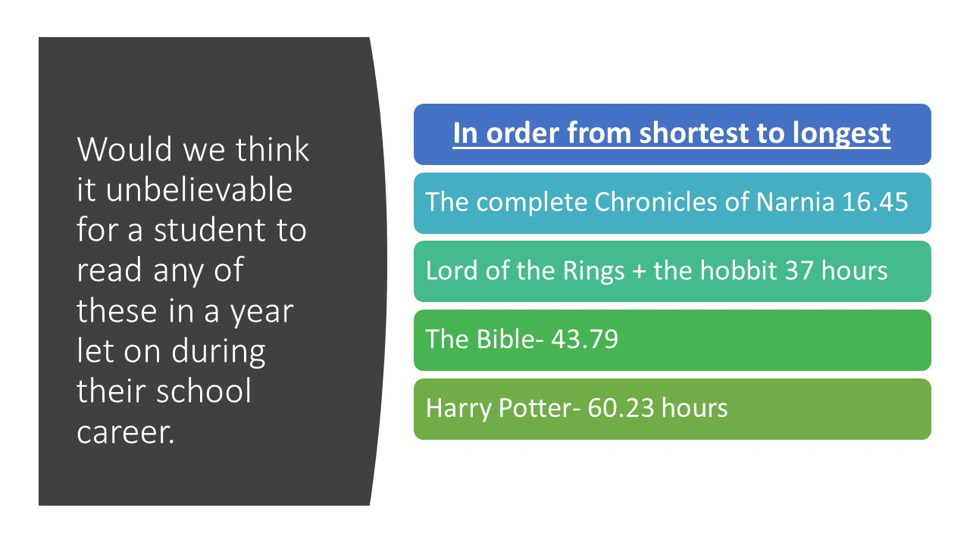
Reason to not fear the FOMO

Engaging and immersing the students in the Bible is far more important than checking off boxes of what we have covered. Take time to develop joy and passion and the knowledge will come.

Realizing the joy and incredible gift of TFT

TFT is all I have known in Christian education and so I may have taken it for granted. It is an amazing tool that we need to fully embrace to help the students. I spent a big part of my trip as a TFT evangelist. Almost everyone I talked to about TFT was enthralled and envious of such a great tool.
Don’t be afraid to put your hands up.
- We need to give up a little control to allow for true student grown.
  - Avoid the Sunday school answers.
  - Giving them control to make it their own.
  - The sooner we give them tools to understand and make their faith their own the better chance we have out helping them develop a lasting faith.

Trying to hit the top of Blooms Taxonomy in Bible Class
From coming back from they Symposium this image has been in my head.
How can a help students having better learning by aiming for the top of Blooms taxonomy with my students.

Using literature: Time Lines and through lines
Through Lines

Keep an eye out for through lines that are in the book. In each chapter we should be able to find examples, themes, expressions or applications of the different through lines.

Each through line explanation needs to include:
- A Through line statement.
- 2-3 reasons why you feel is an example of the through line.
- Examples from the book
Ideas on how to connect the chapters to the through lines
You may want to write about
- What the through line means to you and connect this meaning to something that happened in the book.
- A point in the book where a character acted in a way in which would be an example for the through line.
- A point in the book when a character had an opportunity and failed to act in a way which would be an example of a through line.
- Any other example or opportunity in the book in which a though line could be expressed.
- How we could learn from and apply to our lives an example of a through line being expressed in the book.

Trying to hit the top of Blooms Taxonomy in Bible Class Bible memory.
In all my Bible memories I sure larger sections of scripture and ask4
questions.
- What does the verse mean? (understanding)
- How does it apply to our lives? (apply)
- What through line/ Through lines best fit this verse? (apply/ analyze)
- How does this verse connect to our class storyline?
Trying to hit the top of Blooms Taxonomy in Bible Class
Daily devotions.
Last year I had the students take over devotions. Every round of devotions (about 1-2 months) I would assign each person, including myself, a day to lead the class in devotions.
Each round I had the students focus on a different type of devotion.
- Devotion they do at home
- Song
- Worship song (and actually took time to worship at the start of the day as a class.
- Use it with a combination of Bible memory.

For each devotion I include 1-4 of my Bible memory questions.
- What does the verse mean? (understanding)
- How does it apply to our lives? (apply)
- What through line/ Through lines best fit this verse? (apply/ analyze)
- How does this verse connect to our class storyline?
Student Examples
Living Hope By Phil Wickham
I picked this song because of the message and how I like that it relates to Easter. It means that Jesus freed us from sin and he should be our only hope. Verses that apply to this song are
- Colossians 1:13-14 He has delivered us from the domain of darkness and transferred us to the kingdom of his beloved Son, in whom we have redemption the forgiveness of sins.
- Galations 5:1 Christ has set us free; stand firm therefore; and do not submit again to yoke of slavery.
My Feet are on the Rock By I am They
This song means that God is our rock and our foundation and that fear cannot move us because the Lord is the stronghold of our lives. The throughline that I think applies to this song is God Worshipping because we were created to trust in God and come to him with all of our fears. I picked this song because I like how it says that I can feel the wind as they try to shake me but that I will not be moved my feet are on the rock and the rock is God.
The verses that I think connect to this song would be
- Psalm 27:1 The Lord is my light and my salvation whom shall I fear? The Lord is the stronghold of my life—of whom shall I be afraid?
- Psalm 118:6 The Lord is with me; I will not be afraid What can mere mortals do to me?
- Psalm 118:14 The Lord is my strength and my defense^{[a]} he has become my salvation.
- I picked these verses because they all talk about the Lord being our rock and the strong hold of our lives.

Trying to hit the top of Blooms Taxonomy in Bible Class
Cross curricular involvement Actively using Bible in other classes.

- Parables (apply all the way to create possibly) I incorporate this into my story writing unit.
Using a parable as a starting point for a story.
We will each be taking a parable which Jesus had spoken about and using them as a based to build a story around. We will be filling in the story in a number of different ways.
You will be able to work individually or with a partner.
This could include:
- Modernizing the story- which would be making the story involve situation of the current times as opposed to Biblical times.
- Adding more detail to the story- All of the parable are very short stories. You can add details to the setting, to the development of the plot or to the situations in the story. When doing this remember the unbreakable rule.
- Naming unnamed characters or adding characters. Jesus often said there was a man, a farmer, a sower or a king. You can give these characters names and develop their personalities or characteristics.
- Having the story become more applicable to a certain age group.

The unbreakable rule of this assignment.
- You cannot change the meaning or lesson of the parable. If your story ends up changing the meaning of the parable you will be asked to start all over again.

You be using your story to create a power point animation story book.

- Poetry Up to evaluate
- Talking about Biblical connections to science class.
  - The scientific validity of the Laws of Moses
  - The ideas of purity and pure substances.
  - Creation and science and order.

Trying to hit the top of Blooms Taxonomy in Bible Class
Cross curricular involvement Actively using Bible in other classes.

- Developing research skills up to evaluate
  - I have been slowing gaining resources for Bible research to expand the students knowledge. I incorporate engaging projects as a part of them doing their research.

Bible Trading Card Assignment.
We are going to be making Bible trading cards.  The Card will be based on the People, groups and places in the Bible.  - Requirements  - All cards will need to be hand draw and in full colour  - You will have to research the person, group or place and provide information them.  - In each category there is a list of things that may be included on your card. Anything that has a * beside it is required. You will need to include some of the other elements. There is no minimum requirement the card needs to be completely filled in.  - You are able to decide what format you would like to do your card in. It can be based on any of the examples shown or a design of you own.  - You will need to complete  • 3 people  • 2 groups  • 2 places  • 1 card of your choice | People in the Bible  There are lots of different people in the Bible  - Some of them are super stars that everyone knows like Noah and Moses. There are other people who you know of but may not know a lot about them or what they have done like Aaron or Jacob.  - There are some people which are heroes like David or Joshua  - There are villains like Goliath or Caiaphas.  - Some have small parts like Potiphar (he threw Joseph in jail)  - Others are not even named like the boy with the 5 loaves and 2 fish in the feeding of the 5000.  - Your card may have on them  o Picture*  o Their name*  o Nicknames  o What did they do?  o Strengths and/or weaknesses  o Where in the Bible they are mentioned.  o When and where did they live?  o Relatives  o Fun or interesting facts  o Through lines they exemplify (or the antithesis of a through line)
- Allowing for artistic expression. Up to create.
  - Bible memory inspired art projects

Matthew 5:38-48 Bible Memory Assignment.

The Bible Memory for the month of September will be Matthew 5:38-48. To get familiar with the verse you will be creating a comic strip for the passage. Your comic strip can be as many or as few boxes as you would like but it does need to express the entire bible verse. Feel free to be creative but remember the unbreakable rule when we are working with the Bible “you can not change the meaning of the verse”
Example of a comic strip
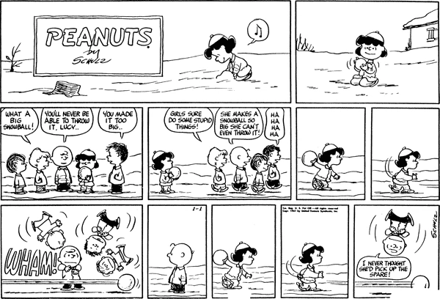
Start but reading the Bible verse on your own. And write down as many brainstorming ideas as you can below
Brain storming on your own

Now find a partner an share your ideas with each other. Write down at least 3 ideas from the other person that you did not think of on your own.

Brainstorming
______________________________________________________________________________________________________________________________________________________________________________________________________________________________________________________________________________________________________________________________________________________________________________________________________________________________________________________________________________________________________________________________________________________________________________________________________________________________________________________________________________________________________________________________________________________________________________________________________________________________________________________________________________________________________________________________________________________________________________________________________________________________________________________________________________________________________________________________________________________________________________________________________________________________________________________________________________________________________________________________________________________________________________________________________________________________________________________________________________________________________________________________________________________________________________________________________________________________________________________________________________________________________________________________________________________________________________________________________________________________________________________________________________________________________________________________________________________________________________________________________________________________________________________________________________________________________________________________________________________________________________________________________________________________________________________________________________________________________________________________________________________________________________________________________________________________________________________________________________________________________________________________________________________________________________________________________________________________________________________________________________________________________________________________________________________________________________________________________________________________________________________________________________________________________________________________________________________________________________________________________________________________________________________________________________________________________________________________________________________________________________________________________________________________________________________________________________________________________________________________________________________________________________________________________________________________________________________________________________________________________________________________________________________________________________________________________________________________________________________

