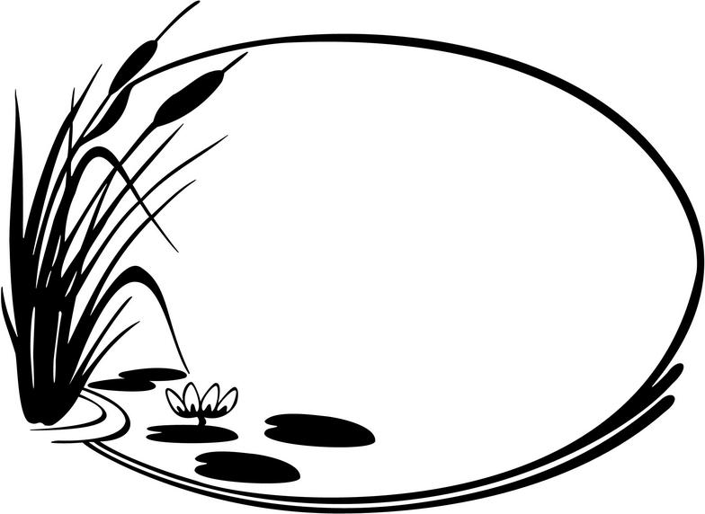

Wetland Infographic
Project

Name: ____________________________________

What we are doing
One big project from now till the end of the year.
- You will be working in groups to complete your own infographic on wetlands
- You will need to have
  - All the information in the workbook.
  - Pictures- both hand drawn and pictures you take.
  - Your information presented in a creative and engaging way.
You will need to research all the information about wetlands from the infobooks, the library books and the webpages provided on Mr. Riewe’s blog.
Groups are to come up with a plan on how you are going to create your infographic however at no time are you allowed to be not working with the excuse “it’s not my turn.”
What is an infographic?
A way of showing a group of related information about a specific topic in an engaging way.
Info Graphics are typically.
  - Colourful
  - Have lots of information
    - Information is presented in Text, Pictures, Graphs and numbers.
  - Has a central design theme.
Who is in my group

___________________
___________________
___________________
___________________

Questions to answer on your Infographic.
What is a wetland?
__________________________________________________________________________________________________________________________________________________________________________________________________________________________________________________________________________________________________________________________________________________________________________________________

Why are wetlands important
__________________________________________________________________________________________________________________________________________________________________________________________________________________________________________________________________________________________________________________________________________________________________________________________

What are 5 different types of wetlands?
__________________________________________________________________________________________________________________________________________________________________________________________________________________________________________________________________________________________________________________________________________________________________________________________

What is an ecosystem?
____________________________________________________________________________________________________________________________________________________________________________________________________________________________________________________________________________________________________________________________________________________________________________________________________________________________________________________________________________________________________________________________________________________________

What is a life cycle? Provide a diagram
__________________________________________________________________________________________________________________________________________________________________________________________________________________________________________________________________________________________________________________________________________________________________________________________

What is a producer? Provide an example. ________________________________________________________________________________________________________________________________________________________________________________________________________________________________________________________________________________________________________________________________________________________________________________________________________________________________________________

What is a consumer? Provide an example ________________________________________________________________________________________________________________________________________________________________________________________________________________________________________________________________________________________________________________________________________________________________________________________________________________________________________________

What is a Herbivore? Provide an example.
____________________________________________________________________________________________________________________________________________________________________________________________________________________________________________________________________________________________________________________________________________________________________________________________________________________________________________________________________________________________________________________________________________________________
What is an Omnivore? Provide an example.
____________________________________________________________________________________________________________________________________________________________________________________________________________________________________________________________________________________________________________________________________________________________________________________________________________________________________________________________________________________________________________________________________________________________
What is a Carnivore? Provide an example.
____________________________________________________________________________________________________________________________________________________________________________________________________________________________________________________________________________________________________________________________________________________________________________________________________________________________________________________________________________________________________________________________________________________________
What is a decomposer? Provide an example.
____________________________________________________________________________________________________________________________________________________________________________________________________________________________________________________________________________________________________________________________________________________________________________________________________________________________________________________________________________________________________________________________________________________________

How are producers, consumers and decomposers all connected? Provide an explanation and a diagram.
____________________________________________________________________________________________________________________________________________________________________________________________________________________________________________________________________________________________________________________________________________________________________________________________________________________________________________________________________________________________________________________________________________________________

What is a food chain? Provide a diagram
________________________________________________________________________________________________________________________________________________________________________________________________________________________________________________________________________________________________________________________________________________________________________________________________________________________________________________

What is a food web? Provide a diagram
________________________________________________________________________________________________________________________________________________________________________________________________________________________________________________________________________________________________________________________________________________________________________________________________________________________________________________

What is the difference between a food chain and a food web?
________________________________________________________________________________________________________________________________________________________________________________________________________________________________________________________________________________________________________________________________________________________________________________________________________________________________________________

Fully describe the way two different animals breathe? (note it will be two different animals)
______________________________________________________________________________________________________________________________________________________________________________________________________________________________________________________________________________________________________________________________________________________________________________________________________________________________________________________________________________________________________________________________________________________________________________________________________________________________________________________________________________________________________________________________________________________________________________________________________________________________________________________________________________________________________________________________________________________________________________________________________________________________________________________________________________________________________________________________________________________________________________________________________________________________________________________________________________________________________________________________________________________________________________________________________________________________________________________________________________________________________________________________________________________________________________________________________________________________________________________________________________________________________________________________________________________________________________________________________________________________________________________________________________________________________________________________________________________________________________________________________________________________________________________________________________________________________________________________________________________________________________________________________________________________________________________________________________________________________________________________________________________________________________________________________________________________________________________________________________________________________________________________
What is an adaptation?
____________________________________________________________________________________________________________________________________________________________________________________________________________________________________________________________________________________________________________________________________________________________________________________________________________________________________________________________________________________________________________________________________________________________
How do adaptations work? What are some ways a species can adapt?
____________________________________________________________________________________________________________________________________________________________________________________________________________________________________________________________________________________________________________________________________________________________________________________________________________________________________________________________________________________________________________________________________________________________
Provide 3 examples of an adaptation and explain why it is an adaptation?
________________________________________________________________________________________________________________________________________________________________________________________________________________________________________________________________________________________________________________________________________________________________________________________________________________________________________________________________________________________________________________________________________________________________________________________________________________________________________________________________________________________________________________________________________________________________________________________________________________________________________________________________________________________________________________________________________________________________________________________________________________________________________________________________________________________________________________________________________________________________________________________________________________________________________________________________________________________________________________________________________________________________________________________________________________________________________________________________________________________________________________________________________________________________________________________________________________________________________________________________________________________________________________________________________________________________________________________________________________________________________________________________________________________________________________________________________________________________________________________________________________________________________________________________________________________________________________________________________________________________________________________________________________________________________________________________________________________________________________________________________________________________________________________________________________________________________________________________________
How does human activity have a negative impact on wetland? Please give at least 3 examples.
______________________________________________________________________________________________________________________________________________________________________________________________________________________________________________________________________________________________________________________________________________________________________________________________________________________________________________________________________________________________________________________________________________________________________________________________________________________________________________________________________________________________________________________________________________________________________________________________________________________________________________________________________________________________________________________________________________________________________________________________________________________________________________________________________________________________________________________

What can be done to stop or prevent human activity from having a negative impact of wetlands?
________________________________________________________________________________________________________________________________________________________________________________________________________________________________________________________________________________________________________________________________________________________________________________________________________________________________________________________________________________________________________________________________________________________________________________________________________________________________________________________________________________________________________________________________________________________________________________________________________________________________________________________________________________________________________________________________________________________________________________________________________________________________________________________________________________________________________________________

Provide 5 additional facts about wetlands.
- ________________________________________________________________________________________________________________________________________________________________________________________________________________________________________________________________________________________________________________________________________________________________________________________________________________________________________________

- ________________________________________________________________________________________________________________________________________________________________________________________________________________________________________________________________________________________________________________________________________________________________________________________________________________________________________________

- ________________________________________________________________________________________________________________________________________________________________________________________________________________________________________________________________________________________________________________________________________________________________________________________________________________________________________________

- ________________________________________________________________________________________________________________________________________________________________________________________________________________________________________________________________________________________________________________________________________________________________________________________________________________________________________________________________________________________________________________________________________________________________________________________________

- ________________________________________________________________________________________________________________________________________________________________________________________________________________________________________________________________________________________________________________________________________________________________________________________________________________________________________________________________________________________________________________________________________________________________________________________________

